Student Dropout Prediction Challenge: Data wrangling to Feature Engineering

Hamed

3/24/2020

This R markdown document contains well commented code and output of the whole process of machine learning from Data wrangling to Modelling.

# DATA WRANGLING

#### Financial aid data loading

financial_aid<-read.csv("financial_aid.csv",header = T)  
summary(financial_aid)

## StudentID cohort_term Marital.Status Adjusted.Gross.Income  
## Min. : 20932 Min. :1.000 : 2154 Min. : -24326   
## 1st Qu.:305677 1st Qu.:1.000 Divorced : 236 1st Qu.: 0   
## Median :322283 Median :1.000 Married : 1024 Median : 2637   
## Mean :317095 Mean :1.451 Separated: 200 Mean : 13125   
## 3rd Qu.:344790 3rd Qu.:1.000 Single :10155 3rd Qu.: 16323   
## Max. :364184 Max. :3.000 Max. :2576425   
## NA's :2154   
## Parent.Adjusted.Gross.Income Father.s.Highest.Grade.Level  
## Min. :-62979 :2292   
## 1st Qu.: 0 College :3284   
## Median : 12372 High School :5092   
## Mean : 28102 Middle School:1330   
## 3rd Qu.: 38587 Unknown :1771   
## Max. :657631   
## NA's :2154   
## Mother.s.Highest.Grade.Level Housing X2012.Loan   
## :2520 :2164 Min. : 337   
## College :3215 Off Campus :5373 1st Qu.: 3500   
## High School :5024 On Campus Housing:1624 Median : 5500   
## Middle School:1296 With Parent :4608 Mean : 7169   
## Unknown :1714 3rd Qu.: 9500   
## Max. :55626   
## NA's :12532   
## X2012.Scholarship X2012.Work.Study X2012.Grant X2013.Loan   
## Min. : 283 Min. : 200 Min. : 79.09 Min. : 103   
## 1st Qu.: 2000 1st Qu.:1700 1st Qu.: 3368.25 1st Qu.: 3500   
## Median : 4000 Median :2000 Median : 5794.00 Median : 5500   
## Mean : 5225 Mean :1873 Mean : 6660.93 Mean : 7156   
## 3rd Qu.: 6000 3rd Qu.:2121 3rd Qu.:10714.00 3rd Qu.: 9500   
## Max. :27632 Max. :3000 Max. :13263.00 Max. :50555   
## NA's :13598 NA's :13666 NA's :12415 NA's :11582   
## X2013.Scholarship X2013.Work.Study X2013.Grant X2014.Loan   
## Min. : 23 Min. : 25 Min. : 162 Min. : 128   
## 1st Qu.: 2000 1st Qu.:2000 1st Qu.: 3683 1st Qu.: 3783   
## Median : 3549 Median :2000 Median : 6089 Median : 6250   
## Mean : 4793 Mean :2084 Mean : 7094 Mean : 7280   
## 3rd Qu.: 6409 3rd Qu.:2200 3rd Qu.:11040 3rd Qu.:10500   
## Max. :28737 Max. :4000 Max. :13790 Max. :49845   
## NA's :13459 NA's :13590 NA's :11450 NA's :11028   
## X2014.Scholarship X2014.Work.Study X2014.Grant X2015.Loan   
## Min. : 100 Min. : 70 Min. : 97.24 Min. : 25   
## 1st Qu.: 2000 1st Qu.:2000 1st Qu.: 3528.00 1st Qu.: 4162   
## Median : 4000 Median :2000 Median : 6245.00 Median : 6250   
## Mean : 4999 Mean :1933 Mean : 7208.11 Mean : 7241   
## 3rd Qu.: 6000 3rd Qu.:2000 3rd Qu.:11725.89 3rd Qu.:10500   
## Max. :38851 Max. :3300 Max. :14001.00 Max. :47824   
## NA's :13353 NA's :13526 NA's :10840 NA's :10718   
## X2015.Scholarship X2015.Work.Study X2015.Grant X2016.Loan   
## Min. : 200 Min. : 10 Min. : 209 Min. : 103   
## 1st Qu.: 2000 1st Qu.:2000 1st Qu.: 3880 1st Qu.: 4500   
## Median : 4000 Median :2000 Median : 6358 Median : 6420   
## Mean : 4755 Mean :2127 Mean : 7370 Mean : 7625   
## 3rd Qu.: 5730 3rd Qu.:2800 3rd Qu.:11592 3rd Qu.:10500   
## Max. :30478 Max. :4600 Max. :19038 Max. :52880   
## NA's :13174 NA's :13520 NA's :10365 NA's :10594   
## X2016.Scholarship X2016.Work.Study X2016.Grant X2017.Loan   
## Min. : 28.3 Min. : 75 Min. : 9.69 Min. : 103   
## 1st Qu.: 2000.0 1st Qu.:2000 1st Qu.: 3963.25 1st Qu.: 5354   
## Median : 4000.0 Median :2000 Median : 6428.00 Median : 6500   
## Mean : 4897.3 Mean :2036 Mean : 7458.96 Mean : 8256   
## 3rd Qu.: 6000.0 3rd Qu.:2000 3rd Qu.:11717.50 3rd Qu.:11812   
## Max. :31265.5 Max. :4000 Max. :18505.00 Max. :60118   
## NA's :13084 NA's :13497 NA's :10075 NA's :10445   
## X2017.Scholarship X2017.Work.Study X2017.Grant   
## Min. : 100 Min. : 45 Min. : 0.1   
## 1st Qu.: 2000 1st Qu.:1500 1st Qu.: 4261.0   
## Median : 4000 Median :2000 Median : 7305.0   
## Mean : 5024 Mean :1929 Mean : 7794.2   
## 3rd Qu.: 6906 3rd Qu.:2000 3rd Qu.:12173.0   
## Max. :33848 Max. :3000 Max. :19823.0   
## NA's :12784 NA's :13402 NA's :9732

* The data loaded has periodic capture financial information whereby variables; loan, workstudy, grant and scholarship are recorded multiple times.
* Therefore to get independent variables out of these variables; Combine by summing the loan, scholarship, grant and work/study data from 2011 to 2017 as follows;

library(tidyverse)

## -- Attaching packages ------------------------------- tidyverse 1.3.0 --

## v ggplot2 3.2.1 v purrr 0.3.3  
## v tibble 2.1.3 v dplyr 0.8.3  
## v tidyr 1.0.0 v stringr 1.4.0  
## v readr 1.3.1 v forcats 0.5.0

## -- Conflicts ---------------------------------- tidyverse_conflicts() --  
## x dplyr::filter() masks stats::filter()  
## x dplyr::lag() masks stats::lag()

attach(financial_aid)  
financial_aid=financial_aid %>%  
 mutate(Total_loan = select(.,c(X2012.Loan,X2013.Loan,X2014.Loan,  
 X2015.Loan,X2016.Loan,X2017.Loan)) %>%  
 rowSums(na.rm = TRUE))  
  
financial_aid<-financial_aid%>%  
 mutate(Total_grant=select(.,c(X2012.Grant,X2013.Grant,X2014.Grant,  
 X2015.Grant,X2016.Grant,X2017.Grant))%>%  
 rowSums(na.rm = TRUE))  
  
financial_aid<-financial_aid%>%  
 mutate(Total_scholarship=select(.,c(X2012.Scholarship,X2013.Scholarship,X2014.Scholarship,  
 X2015.Scholarship,X2016.Scholarship,X2017.Scholarship))%>%  
 rowSums(na.rm = TRUE))  
  
financial_aid<-financial_aid%>%  
 mutate(Total_WorkStudy=select(.,c(X2012.Work.Study,X2013.Work.Study,  
 X2014.Work.Study,X2015.Work.Study,X2016.Work.Study,X2017.Work.Study))%>%  
 rowSums(na.rm = TRUE))  
  
# Variables   
colnames(financial_aid)

## [1] "StudentID" "cohort_term"   
## [3] "Marital.Status" "Adjusted.Gross.Income"   
## [5] "Parent.Adjusted.Gross.Income" "Father.s.Highest.Grade.Level"  
## [7] "Mother.s.Highest.Grade.Level" "Housing"   
## [9] "X2012.Loan" "X2012.Scholarship"   
## [11] "X2012.Work.Study" "X2012.Grant"   
## [13] "X2013.Loan" "X2013.Scholarship"   
## [15] "X2013.Work.Study" "X2013.Grant"   
## [17] "X2014.Loan" "X2014.Scholarship"   
## [19] "X2014.Work.Study" "X2014.Grant"   
## [21] "X2015.Loan" "X2015.Scholarship"   
## [23] "X2015.Work.Study" "X2015.Grant"   
## [25] "X2016.Loan" "X2016.Scholarship"   
## [27] "X2016.Work.Study" "X2016.Grant"   
## [29] "X2017.Loan" "X2017.Scholarship"   
## [31] "X2017.Work.Study" "X2017.Grant"   
## [33] "Total_loan" "Total_grant"   
## [35] "Total_scholarship" "Total_WorkStudy"

Data cleaning : drop the periodic columns after creating the independent variables in order to have relevant columns only.

# drop the extra periodical financial data   
financial_aid<-financial_aid[,-c(9:32)]  
  
# Load the train labels and the TestIDs  
train_labels=read.csv("DropoutTrainLabels.csv",header = T)  
testIDs=read.csv("TestIDs.csv",header = T)

JOIN the train labels and the financial aid data

library(dplyr)  
financial_aid_train=left_join(train_labels,financial_aid,by="StudentID")  
dim(financial_aid_train)

## [1] 12261 13

# JOIN the test IDs and the financial aid data  
financial_aid_test=left_join(testIDs,financial_aid,by="StudentID")  
dim(financial_aid_test)

## [1] 1000 12

Check for duplicated StudentID (TRUE=No duplicates, FALSE=duplicates present)

length(unique(financial_aid_train$StudentID)) == nrow(financial_aid_train)

## [1] TRUE

### STATIC Data

STATIC data files loaded and merged using a function that iterates through a folder and picks up all files loads and merges them into one data frame.

#load all files and merge them  
myETL=function(mypath){  
 filenames = list.files(path=mypath, full.names=TRUE)  
 file_load = function(x){read.csv(file=x,header=T)}  
 datalist = lapply(filenames, file_load)  
 data2 = do.call(rbind, lapply(datalist, as.data.frame))  
 return(data2)  
}  
# call the function  
mergedStatic<-myETL("D:/Hamed/KAGGLE COMPETITION/Student Retention Challenge Data/Student Static Data")  
  
# Variable names in static dataset  
colnames(mergedStatic)

## [1] "StudentID" "Cohort"   
## [3] "CohortTerm" "Campus"   
## [5] "Address1" "Address2"   
## [7] "City" "State"   
## [9] "Zip" "RegistrationDate"   
## [11] "Gender" "BirthYear"   
## [13] "BirthMonth" "Hispanic"   
## [15] "AmericanIndian" "Asian"   
## [17] "Black" "NativeHawaiian"   
## [19] "White" "TwoOrMoreRace"   
## [21] "HSDip" "HSDipYr"   
## [23] "HSGPAUnwtd" "HSGPAWtd"   
## [25] "FirstGen" "DualHSSummerEnroll"   
## [27] "EnrollmentStatus" "NumColCredAttemptTransfer"  
## [29] "NumColCredAcceptTransfer" "CumLoanAtEntry"   
## [31] "HighDeg" "MathPlacement"   
## [33] "EngPlacement" "GatewayMathStatus"   
## [35] "GatewayEnglishStatus"

Check for duplicated StudentID (TRUE=No duplicates, FALSE=duplicates present)

length(unique(mergedStatic$StudentID)) == nrow(mergedStatic)

## [1] TRUE

Since there were no duplicated student IDs, JOIN the train labels & test IDs and the static data

library(dplyr)  
static_train=left_join(train_labels,mergedStatic,by="StudentID")  
summary(static_train)

## StudentID Dropout Cohort CohortTerm   
## Min. : 20932 Min. :0.0000 2011-12:2131 Min. :1.000   
## 1st Qu.:305164 1st Qu.:0.0000 2012-13:2059 1st Qu.:1.000   
## Median :321580 Median :0.0000 2013-14:1936 Median :1.000   
## Mean :316079 Mean :0.3861 2014-15:2080 Mean :1.393   
## 3rd Qu.:343608 3rd Qu.:1.0000 2015-16:2184 3rd Qu.:1.000   
## Max. :359783 Max. :1.0000 2016-17:1871 Max. :3.000   
##   
## Campus Address1   
## Mode:logical : 103   
## NA's:12261 NJCU-Registrar's Office: 6   
## Summit Apts : 5   
## Jackson Garden Apt : 4   
## Westview Towers : 4   
## John F : 4   
## (Other) :12135   
## Address2 City State   
## :11906 Jersey City :3285 NJ :11869   
## 1 : 14 Bayonne :1138 NY : 120   
## 2 : 11 Newark : 683 : 103   
## Apt 2 : 10 North Bergen : 557 FL : 29   
## 2039 John F Kennedy Blvd: 6 Union City : 549 CA : 16   
## 2nd Floor : 5 West New York: 418 MD : 15   
## (Other) : 309 (Other) :5631 (Other): 109   
## Zip RegistrationDate Gender BirthYear   
## Min. : 747 Min. :20110111 Min. :1.000 Min. :1945   
## 1st Qu.: 7060 1st Qu.:20120710 1st Qu.:1.000 1st Qu.:1986   
## Median : 7304 Median :20140122 Median :2.000 Median :1991   
## Mean : 7800 Mean :20136172 Mean :1.597 Mean :1989   
## 3rd Qu.: 7307 3rd Qu.:20150624 3rd Qu.:2.000 3rd Qu.:1994   
## Max. :98118 Max. :20160912 Max. :2.000 Max. :2000   
## NA's :121 NA's :1   
## BirthMonth Hispanic AmericanIndian Asian   
## Min. : 1.000 Min. :-1.0000 Min. :-1.0000 Min. :-1.00000   
## 1st Qu.: 4.000 1st Qu.: 0.0000 1st Qu.: 0.0000 1st Qu.: 0.00000   
## Median : 7.000 Median : 0.0000 Median : 0.0000 Median : 0.00000   
## Mean : 6.585 Mean : 0.2567 Mean :-0.0668 Mean : 0.01974   
## 3rd Qu.:10.000 3rd Qu.: 1.0000 3rd Qu.: 0.0000 3rd Qu.: 0.00000   
## Max. :12.000 Max. : 1.0000 Max. : 1.0000 Max. : 1.00000   
##   
## Black NativeHawaiian White TwoOrMoreRace   
## Min. :-1.0000 Min. :-1.00000 Min. :-1.0000 Min. :-1.00000   
## 1st Qu.: 0.0000 1st Qu.: 0.00000 1st Qu.: 0.0000 1st Qu.: 0.00000   
## Median : 0.0000 Median : 0.00000 Median : 0.0000 Median : 0.00000   
## Mean : 0.1467 Mean :-0.06696 Mean : 0.1824 Mean :-0.05122   
## 3rd Qu.: 0.0000 3rd Qu.: 0.00000 3rd Qu.: 1.0000 3rd Qu.: 0.00000   
## Max. : 1.0000 Max. : 1.00000 Max. : 1.0000 Max. : 1.00000   
##   
## HSDip HSDipYr HSGPAUnwtd HSGPAWtd FirstGen   
## Min. :-1.0000 Min. : -1.0 Min. :-1.0000 Min. :-1 Min. :-1   
## 1st Qu.: 1.0000 1st Qu.: -1.0 1st Qu.:-1.0000 1st Qu.:-1 1st Qu.:-1   
## Median : 1.0000 Median : -1.0 Median :-1.0000 Median :-1 Median :-1   
## Mean : 0.9647 Mean : 547.6 Mean : 0.1395 Mean :-1 Mean :-1   
## 3rd Qu.: 1.0000 3rd Qu.:2010.0 3rd Qu.: 2.3800 3rd Qu.:-1 3rd Qu.:-1   
## Max. : 4.0000 Max. :2016.0 Max. : 4.0000 Max. :-1 Max. :-1   
##   
## DualHSSummerEnroll EnrollmentStatus NumColCredAttemptTransfer  
## Min. :0 Min. :1.000 Min. : -2.00   
## 1st Qu.:0 1st Qu.:1.000 1st Qu.: -2.00   
## Median :0 Median :2.000 Median : 16.00   
## Mean :0 Mean :1.596 Mean : 37.46   
## 3rd Qu.:0 3rd Qu.:2.000 3rd Qu.: 73.00   
## Max. :0 Max. :2.000 Max. :150.00   
##   
## NumColCredAcceptTransfer CumLoanAtEntry HighDeg MathPlacement   
## Min. :-2.00 Min. :-2.000 Min. :0.0000 Min. :-1.0000   
## 1st Qu.:-2.00 1st Qu.:-2.000 1st Qu.:0.0000 1st Qu.: 0.0000   
## Median :24.00 Median :-1.000 Median :0.0000 Median : 0.0000   
## Mean :32.14 Mean :-1.404 Mean :0.5912 Mean : 0.2742   
## 3rd Qu.:66.00 3rd Qu.:-1.000 3rd Qu.:2.0000 3rd Qu.: 1.0000   
## Max. :96.00 Max. :-1.000 Max. :4.0000 Max. : 1.0000   
##   
## EngPlacement GatewayMathStatus GatewayEnglishStatus  
## Min. :-1.0000 Min. :0.0000 Min. :0.0000   
## 1st Qu.: 0.0000 1st Qu.:0.0000 1st Qu.:0.0000   
## Median : 0.0000 Median :0.0000 Median :0.0000   
## Mean : 0.1839 Mean :0.1196 Mean :0.1871   
## 3rd Qu.: 0.0000 3rd Qu.:0.0000 3rd Qu.:0.0000   
## Max. : 1.0000 Max. :1.0000 Max. :1.0000   
##

# JOIN the test IDs and the static data  
static_test=left_join(testIDs,mergedStatic,by="StudentID")

### PROGRESS Data

Loaded and merged using a function that iterates through a folder and picks up all files loads and merges them into one data frame.

myETL=function(mypath){  
filenames = list.files(path=mypath, full.names=TRUE)  
file_load = function(x){read.csv(file=x,header=T)}  
datalist = lapply(filenames, file_load)  
data2 = do.call(rbind, lapply(datalist, as.data.frame))  
return(data2)  
}  
  
# call the function  
mergedProgress<-myETL("D:/Hamed/KAGGLE COMPETITION/Student Retention Challenge Data/Student Progress Data")  
  
# variable names in the progress data  
colnames(mergedProgress)

## [1] "StudentID" "Cohort" "CohortTerm"   
## [4] "Term" "AcademicYear" "CompleteDevMath"   
## [7] "CompleteDevEnglish" "Major1" "Major2"   
## [10] "Complete1" "Complete2" "CompleteCIP1"   
## [13] "CompleteCIP2" "TransferIntent" "DegreeTypeSought"   
## [16] "TermGPA" "CumGPA"

dim(mergedProgress)

## [1] 57945 17

Check for duplicated StudentID (TRUE=No duplicates, FALSE=duplicates present)

length(unique(mergedProgress$StudentID)) == nrow(mergedProgress)

## [1] FALSE

* The data had alot of duplicated student IDs thus to get only unique student ID the data frame was summarised and grouped by student ID.
* Thereafter a left join with the train labels to capter the students appearing only in the train labels data frame.

library(plyr)

## ------------------------------------------------------------------------------

## You have loaded plyr after dplyr - this is likely to cause problems.  
## If you need functions from both plyr and dplyr, please load plyr first, then dplyr:  
## library(plyr); library(dplyr)

## ------------------------------------------------------------------------------

##   
## Attaching package: 'plyr'

## The following objects are masked from 'package:dplyr':  
##   
## arrange, count, desc, failwith, id, mutate, rename, summarise,  
## summarize

## The following object is masked from 'package:purrr':  
##   
## compact

prog1=ddply(mergedProgress,.(StudentID),summarize,  
 CompleteDevMath=mean(CompleteDevMath),CompleteDevEnglish=mean(CompleteDevEnglish),  
 Major1=mean(Major1),Major2=mean(Major2),Complete1=mean(Complete1),  
 Complete2=mean(Complete2),CompleteCIP1=mean(CompleteCIP1),  
 CompleteCIP2=mean(CompleteCIP2),TransferIntent=mean(TransferIntent),  
 DegreeTypeSought=mean(DegreeTypeSought),TermGPA=mean(CumGPA),  
 CumGPA=mean(CumGPA),number=length(StudentID))  
dim(prog1)

## [1] 13767 14

# drop the irrelevant frequency column  
prog1<-prog1[,-14]  
dim(prog1)

## [1] 13767 13

# JOIN the train labels and the progress data  
library(dplyr)  
progress_train=left_join(train_labels,prog1,by="StudentID")  
# JOIN the test IDs and the progress data  
progress_test=left_join(testIDs,prog1,by="StudentID")  
  
dim(progress_train)

## [1] 12261 14

# variables names for the progress data  
summary(progress_train)

## StudentID Dropout CompleteDevMath CompleteDevEnglish  
## Min. : 20932 Min. :0.0000 Min. :-2.000 Min. :-2.000   
## 1st Qu.:305164 1st Qu.:0.0000 1st Qu.:-2.000 1st Qu.:-2.000   
## Median :321580 Median :0.0000 Median :-2.000 Median :-2.000   
## Mean :316079 Mean :0.3861 Mean :-1.258 Mean :-1.426   
## 3rd Qu.:343608 3rd Qu.:1.0000 3rd Qu.: 0.000 3rd Qu.:-1.000   
## Max. :359783 Max. :1.0000 Max. : 1.000 Max. : 1.000   
## Major1 Major2 Complete1 Complete2  
## Min. :-1.00 Min. :-1.000 Min. :0.0000 Min. :0   
## 1st Qu.:26.01 1st Qu.:-1.000 1st Qu.:0.0000 1st Qu.:0   
## Median :43.02 Median :-1.000 Median :0.0000 Median :0   
## Mean :36.62 Mean :-0.136 Mean :0.4482 Mean :0   
## 3rd Qu.:51.38 3rd Qu.:-1.000 3rd Qu.:0.7778 3rd Qu.:0   
## Max. :54.01 Max. :52.140 Max. :4.0000 Max. :0   
## CompleteCIP1 CompleteCIP2 TransferIntent DegreeTypeSought  
## Min. :-2.0000 Min. :-2 Min. :-1 Min. :6   
## 1st Qu.:-2.0000 1st Qu.:-2 1st Qu.:-1 1st Qu.:6   
## Median :-2.0000 Median :-2 Median :-1 Median :6   
## Mean : 0.7489 Mean :-2 Mean :-1 Mean :6   
## 3rd Qu.: 2.0927 3rd Qu.:-2 3rd Qu.:-1 3rd Qu.:6   
## Max. :26.0051 Max. :-2 Max. :-1 Max. :6   
## TermGPA CumGPA   
## Min. :0.000 Min. :0.000   
## 1st Qu.:2.395 1st Qu.:2.395   
## Median :3.075 Median :3.075   
## Mean :2.817 Mean :2.817   
## 3rd Qu.:3.578 3rd Qu.:3.578   
## Max. :4.000 Max. :4.000

Check to ensure that all the datasets are of the same row and column sizes before merging them

dim(financial_aid_train)

## [1] 12261 13

dim(financial_aid_test)

## [1] 1000 12

dim(static_train)

## [1] 12261 36

dim(static_test)

## [1] 1000 35

dim(progress_train)

## [1] 12261 14

dim(progress_test)

## [1] 1000 13

### TRAINING DATASET

* The train data set was created by use of a inner join function between financial , static and progress. The same was done for test data.
* The data was cleaned by removing irrelevant(duplicated) columns and and renaming the Dropout variable.
* The missing values were clearly assigned NA’s to make sure all of them are identified.
* The categorical variables with wrong data types were corrected and assigned factor data types.

library(dplyr)  
join1<-inner_join(financial_aid_train,static_train,by="StudentID")  
TRAIN_DATA=inner_join(join1,progress_train,by="StudentID")  
colnames(TRAIN_DATA)

## [1] "StudentID" "Dropout.x"   
## [3] "cohort_term" "Marital.Status"   
## [5] "Adjusted.Gross.Income" "Parent.Adjusted.Gross.Income"  
## [7] "Father.s.Highest.Grade.Level" "Mother.s.Highest.Grade.Level"  
## [9] "Housing" "Total_loan"   
## [11] "Total_grant" "Total_scholarship"   
## [13] "Total_WorkStudy" "Dropout.y"   
## [15] "Cohort" "CohortTerm"   
## [17] "Campus" "Address1"   
## [19] "Address2" "City"   
## [21] "State" "Zip"   
## [23] "RegistrationDate" "Gender"   
## [25] "BirthYear" "BirthMonth"   
## [27] "Hispanic" "AmericanIndian"   
## [29] "Asian" "Black"   
## [31] "NativeHawaiian" "White"   
## [33] "TwoOrMoreRace" "HSDip"   
## [35] "HSDipYr" "HSGPAUnwtd"   
## [37] "HSGPAWtd" "FirstGen"   
## [39] "DualHSSummerEnroll" "EnrollmentStatus"   
## [41] "NumColCredAttemptTransfer" "NumColCredAcceptTransfer"   
## [43] "CumLoanAtEntry" "HighDeg"   
## [45] "MathPlacement" "EngPlacement"   
## [47] "GatewayMathStatus" "GatewayEnglishStatus"   
## [49] "Dropout" "CompleteDevMath"   
## [51] "CompleteDevEnglish" "Major1"   
## [53] "Major2" "Complete1"   
## [55] "Complete2" "CompleteCIP1"   
## [57] "CompleteCIP2" "TransferIntent"   
## [59] "DegreeTypeSought" "TermGPA"   
## [61] "CumGPA"

dim(TRAIN_DATA)

## [1] 12261 61

# TESTING DATASET  
join2<-inner_join(financial_aid_test,static_test,by="StudentID")  
TEST_DATA<-inner_join(join2,progress_test,by="StudentID")  
dim(TEST_DATA)

## [1] 1000 58

# Clean the train data by removing extra dropout variables (Dropout.y,Dropout)  
TRAIN_DATA<-select(TRAIN_DATA,-c("Dropout.y"))  
TRAIN_DATA<-select(TRAIN_DATA,-c("Dropout"))  
  
# Rename the droput.x to just dropout for consistency  
library(dplyr)  
colnames(TRAIN_DATA)[colnames(TRAIN_DATA)=="Dropout.x"] <- "Dropout"  
  
dim(TRAIN_DATA)

## [1] 12261 59

dim(TEST_DATA)

## [1] 1000 58

# The response variable  
TRAIN_DATA$Dropout[1:5]

## [1] 0 0 0 0 0

# The features of our project that will be analysed further  
colnames(TEST_DATA)

## [1] "StudentID" "cohort_term"   
## [3] "Marital.Status" "Adjusted.Gross.Income"   
## [5] "Parent.Adjusted.Gross.Income" "Father.s.Highest.Grade.Level"  
## [7] "Mother.s.Highest.Grade.Level" "Housing"   
## [9] "Total_loan" "Total_grant"   
## [11] "Total_scholarship" "Total_WorkStudy"   
## [13] "Cohort" "CohortTerm"   
## [15] "Campus" "Address1"   
## [17] "Address2" "City"   
## [19] "State" "Zip"   
## [21] "RegistrationDate" "Gender"   
## [23] "BirthYear" "BirthMonth"   
## [25] "Hispanic" "AmericanIndian"   
## [27] "Asian" "Black"   
## [29] "NativeHawaiian" "White"   
## [31] "TwoOrMoreRace" "HSDip"   
## [33] "HSDipYr" "HSGPAUnwtd"   
## [35] "HSGPAWtd" "FirstGen"   
## [37] "DualHSSummerEnroll" "EnrollmentStatus"   
## [39] "NumColCredAttemptTransfer" "NumColCredAcceptTransfer"   
## [41] "CumLoanAtEntry" "HighDeg"   
## [43] "MathPlacement" "EngPlacement"   
## [45] "GatewayMathStatus" "GatewayEnglishStatus"   
## [47] "CompleteDevMath" "CompleteDevEnglish"   
## [49] "Major1" "Major2"   
## [51] "Complete1" "Complete2"   
## [53] "CompleteCIP1" "CompleteCIP2"   
## [55] "TransferIntent" "DegreeTypeSought"   
## [57] "TermGPA" "CumGPA"

# Convert empty spaces and (-1) to NULL in order to facilitate imputation later on  
TRAIN_DATA[TRAIN_DATA=="-1"]<-NA  
TRAIN_DATA[TRAIN_DATA==""]<-NA  
  
  
# Convert the theorically categorical variables to factors   
names=c('DegreeTypeSought','TransferIntent','CompleteDevEnglish','CompleteDevMath',  
 'GatewayEnglishStatus','GatewayMathStatus','EngPlacement','MathPlacement',  
 'HighDeg','EnrollmentStatus','FirstGen','HSDip','BirthMonth','BirthYear',  
 'Gender','Campus','CohortTerm','cohort_term','Dropout')  
  
TRAIN_DATA[,names] <- lapply(TRAIN_DATA[,names] , factor)  
str(TRAIN_DATA)

## 'data.frame': 12261 obs. of 59 variables:  
## $ StudentID : int 285848 302176 301803 302756 301067 297371 273211 302772 280023 300412 ...  
## $ Dropout : Factor w/ 2 levels "0","1": 1 1 1 1 1 2 2 2 1 2 ...  
## $ cohort_term : Factor w/ 2 levels "1","3": 1 1 1 1 1 1 1 1 1 1 ...  
## $ Marital.Status : Factor w/ 5 levels "","Divorced",..: 3 NA 5 NA 3 5 5 5 5 5 ...  
## $ Adjusted.Gross.Income : int 116846 NA 1528 NA 69036 0 0 2069 10033 3602 ...  
## $ Parent.Adjusted.Gross.Income: int 0 NA 0 NA 0 0 0 73993 19467 65801 ...  
## $ Father.s.Highest.Grade.Level: Factor w/ 5 levels "","College","High School",..: 3 NA 2 NA 4 5 2 2 5 3 ...  
## $ Mother.s.Highest.Grade.Level: Factor w/ 5 levels "","College","High School",..: 2 NA 3 NA 3 2 3 2 3 3 ...  
## $ Housing : Factor w/ 4 levels "","Off Campus",..: 2 NA 2 NA 2 4 3 4 4 3 ...  
## $ Total_loan : num 35000 28896 54057 0 0 ...  
## $ Total_grant : num 0 0 0 0 0 ...  
## $ Total_scholarship : num 0 0 0 0 21643 ...  
## $ Total_WorkStudy : num 0 0 0 0 0 0 0 0 0 745 ...  
## $ Cohort : Factor w/ 6 levels "2011-12","2012-13",..: 1 1 1 1 1 1 1 1 1 1 ...  
## $ CohortTerm : Factor w/ 2 levels "1","3": 1 1 1 1 1 1 1 1 1 1 ...  
## $ Campus : Factor w/ 0 levels: NA NA NA NA NA NA NA NA NA NA ...  
## $ Address1 : Factor w/ 12704 levels "","1 Brookside Ave",..: 916 279 168 954 673 370 769 1347 750 1275 ...  
## $ Address2 : Factor w/ 291 levels "","#5","1 St. Floor",..: NA NA NA NA NA NA NA NA NA NA ...  
## $ City : Factor w/ 677 levels "","Allentown",..: 102 110 194 110 110 110 39 207 110 111 ...  
## $ State : Factor w/ 40 levels "","AZ","CA","CO",..: 15 15 11 15 15 15 15 15 15 20 ...  
## $ Zip : int 7030 7305 4769 7302 7302 7305 7306 8872 7307 2919 ...  
## $ RegistrationDate : int 20110808 20110804 20110809 20110823 20110420 20110628 20110810 20110908 20110714 20110607 ...  
## $ Gender : Factor w/ 2 levels "1","2": 2 1 2 2 1 2 2 1 2 2 ...  
## $ BirthYear : Factor w/ 55 levels "1945","1946",..: 33 25 39 41 24 47 41 45 42 48 ...  
## $ BirthMonth : Factor w/ 12 levels "1","2","3","4",..: 9 4 4 1 4 8 8 6 12 2 ...  
## $ Hispanic : int 0 0 0 0 0 0 NA NA 1 0 ...  
## $ AmericanIndian : int 0 0 0 0 0 0 NA NA 0 0 ...  
## $ Asian : int 0 0 0 0 0 0 NA NA 0 0 ...  
## $ Black : int 0 0 0 0 0 1 NA NA 0 1 ...  
## $ NativeHawaiian : int 0 0 0 0 0 0 NA NA 0 0 ...  
## $ White : int 1 1 1 1 1 0 NA NA 0 0 ...  
## $ TwoOrMoreRace : int 0 0 0 0 0 0 NA NA 0 0 ...  
## $ HSDip : Factor w/ 3 levels "1","2","4": 1 1 1 NA 1 1 1 1 1 1 ...  
## $ HSDipYr : int NA NA NA NA NA 2010 NA NA NA 2011 ...  
## $ HSGPAUnwtd : num NA NA NA NA NA 3.5 NA NA NA 2.5 ...  
## $ HSGPAWtd : int NA NA NA NA NA NA NA NA NA NA ...  
## $ FirstGen : Factor w/ 0 levels: NA NA NA NA NA NA NA NA NA NA ...  
## $ DualHSSummerEnroll : int 0 0 0 0 0 0 0 0 0 0 ...  
## $ EnrollmentStatus : Factor w/ 2 levels "1","2": 2 2 2 2 2 1 2 2 2 1 ...  
## $ NumColCredAttemptTransfer : num 0 96 0 54 70 -2 62 53 52 -2 ...  
## $ NumColCredAcceptTransfer : num 0 45 0 87.5 66 -2 66 45 66 -2 ...  
## $ CumLoanAtEntry : int NA NA NA NA NA -2 NA NA NA -2 ...  
## $ HighDeg : Factor w/ 4 levels "0","2","3","4": 1 1 1 1 2 1 2 1 1 1 ...  
## $ MathPlacement : Factor w/ 2 levels "0","1": 1 1 1 1 1 1 1 1 1 2 ...  
## $ EngPlacement : Factor w/ 2 levels "0","1": 1 1 1 1 1 2 1 1 1 1 ...  
## $ GatewayMathStatus : Factor w/ 2 levels "0","1": 1 1 1 1 1 2 1 1 1 1 ...  
## $ GatewayEnglishStatus : Factor w/ 2 levels "0","1": 1 1 1 1 1 1 1 1 1 1 ...  
## $ CompleteDevMath : Factor w/ 36 levels "-2","-0.5","0",..: 1 1 1 1 1 1 1 1 1 3 ...  
## $ CompleteDevEnglish : Factor w/ 40 levels "-2","-1.5","-1.25",..: 1 1 1 1 1 23 1 1 1 1 ...  
## $ Major1 : num 51.2 51.4 51.2 45.1 23 ...  
## $ Major2 : num NA NA NA NA 13.1 ...  
## $ Complete1 : num 2.667 1.333 2.667 1.75 0.875 ...  
## $ Complete2 : num 0 0 0 0 0 0 0 0 0 0 ...  
## $ CompleteCIP1 : num 15.8 6.9 15.8 9.77 1.13 ...  
## $ CompleteCIP2 : num -2 -2 -2 -2 -2 -2 -2 -2 -2 -2 ...  
## $ TransferIntent : Factor w/ 0 levels: NA NA NA NA NA NA NA NA NA NA ...  
## $ DegreeTypeSought : Factor w/ 1 level "6": 1 1 1 1 1 1 1 1 1 1 ...  
## $ TermGPA : num 3.48 3.54 3.94 3.79 4 ...  
## $ CumGPA : num 3.48 3.54 3.94 3.79 4 ...

# EXPLORATORY DATA ANALYSIS

We use ggplot for our boxplots, bar plots, scatter plots to display insightful analysis

library(ggplot2)  
# Summarize the data  
summary(TRAIN_DATA)

## StudentID Dropout cohort_term Marital.Status Adjusted.Gross.Income  
## Min. : 20932 0:7527 1:9851 : 0 Min. : -24326   
## 1st Qu.:305164 1:4734 3:2410 Divorced : 208 1st Qu.: 0   
## Median :321580 Married : 924 Median : 2768   
## Mean :316079 Separated: 185 Mean : 13263   
## 3rd Qu.:343608 Single :9103 3rd Qu.: 16491   
## Max. :359783 NA's :1841 Max. :2576425   
## NA's :1841   
## Parent.Adjusted.Gross.Income Father.s.Highest.Grade.Level  
## Min. :-49406 : 0   
## 1st Qu.: 0 College :2916   
## Median : 12373 High School :4578   
## Mean : 28318 Middle School:1201   
## 3rd Qu.: 38805 Unknown :1598   
## Max. :657631 NA's :1968   
## NA's :1841   
## Mother.s.Highest.Grade.Level Housing Total_loan   
## : 0 : 0 Min. : 0   
## College :2896 Off Campus :4846 1st Qu.: 0   
## High School :4516 On Campus Housing:1430 Median : 3745   
## Middle School:1153 With Parent :4120 Mean : 8834   
## Unknown :1535 NA's :1865 3rd Qu.: 13429   
## NA's :2161 Max. :100960   
##   
## Total_grant Total_scholarship Total_WorkStudy Cohort CohortTerm  
## Min. : 0 Min. : 0 Min. : 0.0 2011-12:2131 1:9851   
## 1st Qu.: 0 1st Qu.: 0 1st Qu.: 0.0 2012-13:2059 3:2410   
## Median : 5265 Median : 0 Median : 0.0 2013-14:1936   
## Mean : 9690 Mean : 1170 Mean : 208.5 2014-15:2080   
## 3rd Qu.:14100 3rd Qu.: 0 3rd Qu.: 0.0 2015-16:2184   
## Max. :80873 Max. :125497 Max. :14820.0 2016-17:1871   
##   
## Campus Address1 Address2   
## NA's:12261 NJCU-Registrar's Office: 6 1 : 14   
## Summit Apts : 5 2 : 11   
## Jackson Garden Apt : 4 Apt 2 : 10   
## Westview Towers : 4 2039 John F Kennedy Blvd: 6   
## John F : 4 2nd Floor : 5   
## (Other) :12135 (Other) : 309   
## NA's : 103 NA's :11906   
## City State Zip RegistrationDate   
## Jersey City :3285 NJ :11869 Min. : 747 Min. :20110111   
## Bayonne :1138 NY : 120 1st Qu.: 7060 1st Qu.:20120710   
## Newark : 683 FL : 29 Median : 7304 Median :20140122   
## North Bergen: 557 CA : 16 Mean : 7800 Mean :20136172   
## Union City : 549 MD : 15 3rd Qu.: 7307 3rd Qu.:20150624   
## (Other) :5945 (Other): 109 Max. :98118 Max. :20160912   
## NA's : 104 NA's : 103 NA's :121   
## Gender BirthYear BirthMonth Hispanic AmericanIndian   
## 1:4947 1993 :1173 9 :1119 Min. :0.0000 Min. :0.000   
## 2:7314 1994 :1051 7 :1098 1st Qu.:0.0000 1st Qu.:0.000   
## 1995 : 864 8 :1093 Median :0.0000 Median :0.000   
## 1992 : 832 1 :1058 Mean :0.3494 Mean :0.002   
## 1996 : 811 10 :1029 3rd Qu.:1.0000 3rd Qu.:0.000   
## (Other):7529 12 :1028 Max. :1.0000 Max. :1.000   
## NA's : 1 (Other):5836 NA's :842 NA's :842   
## Asian Black NativeHawaiian White   
## Min. :0.0000 Min. :0.0000 Min. :0.0000 Min. :0.0000   
## 1st Qu.:0.0000 1st Qu.:0.0000 1st Qu.:0.0000 1st Qu.:0.0000   
## Median :0.0000 Median :0.0000 Median :0.0000 Median :0.0000   
## Mean :0.0949 Mean :0.2313 Mean :0.0018 Mean :0.2696   
## 3rd Qu.:0.0000 3rd Qu.:0.0000 3rd Qu.:0.0000 3rd Qu.:1.0000   
## Max. :1.0000 Max. :1.0000 Max. :1.0000 Max. :1.0000   
## NA's :842 NA's :842 NA's :842 NA's :842   
## TwoOrMoreRace HSDip HSDipYr HSGPAUnwtd HSGPAWtd   
## Min. :0.0000 1 :11916 Min. :1963 Min. :0.900 Min. : NA   
## 1st Qu.:0.0000 2 : 69 1st Qu.:2011 1st Qu.:2.500 1st Qu.: NA   
## Median :0.0000 4 : 10 Median :2013 Median :2.880 Median : NA   
## Mean :0.0187 NA's: 266 Mean :2013 Mean :2.909 Mean :NaN   
## 3rd Qu.:0.0000 3rd Qu.:2015 3rd Qu.:3.300 3rd Qu.: NA   
## Max. :1.0000 Max. :2016 Max. :4.000 Max. : NA   
## NA's :842 NA's :8921 NA's :8687 NA's :12261   
## FirstGen DualHSSummerEnroll EnrollmentStatus NumColCredAttemptTransfer  
## NA's:12261 Min. :0 1:4952 Min. : -2.00   
## 1st Qu.:0 2:7309 1st Qu.: -2.00   
## Median :0 Median : 24.00   
## Mean :0 Mean : 38.66   
## 3rd Qu.:0 3rd Qu.: 74.00   
## Max. :0 Max. :150.00   
## NA's :370   
## NumColCredAcceptTransfer CumLoanAtEntry HighDeg MathPlacement EngPlacement  
## Min. :-2.00 Min. :-2 0:8710 0 :7859 0 :8966   
## 1st Qu.:-2.00 1st Qu.:-2 2:3406 1 :3882 1 :2775   
## Median :24.00 Median :-2 3: 143 NA's: 520 NA's: 520   
## Mean :32.14 Mean :-2 4: 2   
## 3rd Qu.:66.00 3rd Qu.:-2   
## Max. :96.00 Max. :-2   
## NA's :1 NA's :7309   
## GatewayMathStatus GatewayEnglishStatus CompleteDevMath CompleteDevEnglish  
## 0:10794 0:9967 -2 :7854 -2 :8860   
## 1: 1467 1:2294 0 :1478 0 : 773   
## 0.5 : 443 0.5 : 319   
## 0.25 : 379 1 : 311   
## 1 : 213 0.25 : 197   
## (Other):1371 (Other):1274   
## NA's : 523 NA's : 527   
## Major1 Major2 Complete1 Complete2  
## Min. :-0.50 Min. : 0.003 Min. :0.0000 Min. :0   
## 1st Qu.:26.01 1st Qu.: 6.060 1st Qu.:0.0000 1st Qu.:0   
## Median :43.02 Median : 9.575 Median :0.0000 Median :0   
## Mean :37.02 Mean :12.564 Mean :0.4482 Mean :0   
## 3rd Qu.:51.38 3rd Qu.:13.121 3rd Qu.:0.7778 3rd Qu.:0   
## Max. :54.01 Max. :52.140 Max. :4.0000 Max. :0   
## NA's :129 NA's :11480   
## CompleteCIP1 CompleteCIP2 TransferIntent DegreeTypeSought  
## Min. :-2.0000 Min. :-2 NA's:12261 6:12261   
## 1st Qu.:-2.0000 1st Qu.:-2   
## Median :-2.0000 Median :-2   
## Mean : 0.7489 Mean :-2   
## 3rd Qu.: 2.0927 3rd Qu.:-2   
## Max. :26.0051 Max. :-2   
##   
## TermGPA CumGPA   
## Min. :0.000 Min. :0.000   
## 1st Qu.:2.395 1st Qu.:2.395   
## Median :3.075 Median :3.075   
## Mean :2.817 Mean :2.817   
## 3rd Qu.:3.578 3rd Qu.:3.578   
## Max. :4.000 Max. :4.000   
##

# Visualize the financial information in relation to the dropout variable whereby we look at the distribution (mean, outliers and spread) of each variable grouped by the dropout variable  
  
library(dplyr)  
ggplot(data = TRAIN_DATA, mapping = aes(x =Dropout,y=Total_loan))+  
 ggtitle("Total_loan in grouped by dropout") +  
 geom_boxplot()

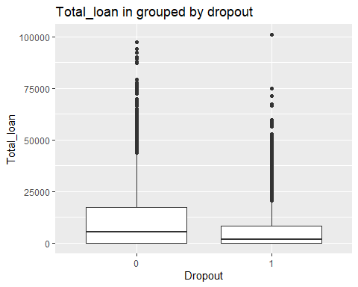

ggplot(data = TRAIN_DATA, mapping = aes(x =Dropout,y=Total_grant))+  
 ggtitle("Total_grant grouped by dropout") +  
 geom_boxplot()

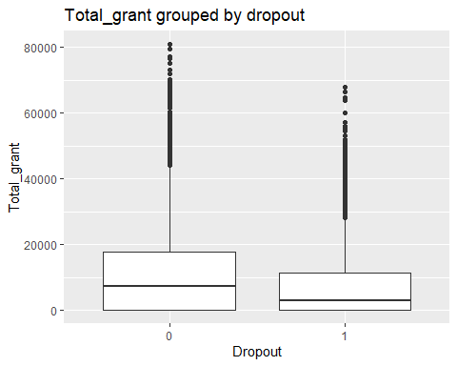

ggplot(data = TRAIN_DATA, mapping = aes(x =Dropout,y=Total_scholarship))+  
 ggtitle("Total_scholarship grouped by dropout") +  
 geom_boxplot()

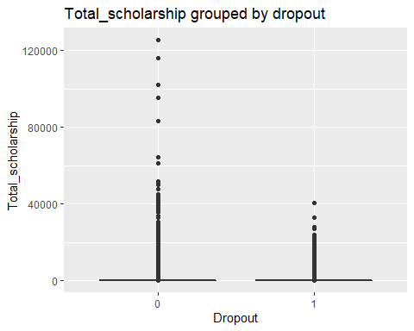

ggplot(data = TRAIN_DATA, mapping = aes(x =Dropout,y=Total_WorkStudy))+  
ggtitle("Total_WorkStudy grouped by dropout") +  
 geom_boxplot()

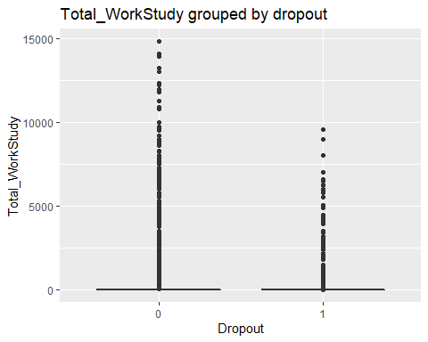

Visualize the student performance information in relation to the dropout variable whereby we look at the distribution (mean, outliers and spread) of each variable grouped by the dropout variable

ggplot(data = TRAIN_DATA, mapping = aes(x =Dropout,y=TermGPA))+  
 ggtitle("TermGPA grouped by dropout") +  
 geom_boxplot()

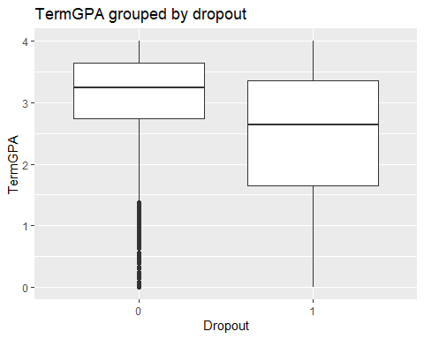

ggplot(data = TRAIN_DATA, mapping = aes(x =Dropout,y=CumGPA))+  
 ggtitle("Total_scholarship grouped by dropout") +  
 geom_boxplot()

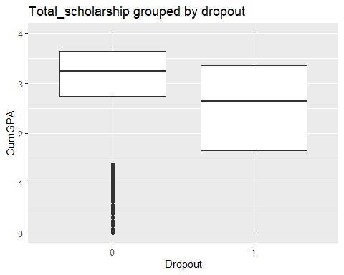

Frequency analysis for categorical variables in relation to the Dropout variable

# Dropout summary statistics  
table(TRAIN_DATA$Dropout,exclude = NULL)

##   
## 0 1   
## 7527 4734

ggplot(data = TRAIN_DATA) +  
 ggtitle("Student Dropout") +  
 geom_bar(mapping = aes(x = Dropout,fill='blue'))

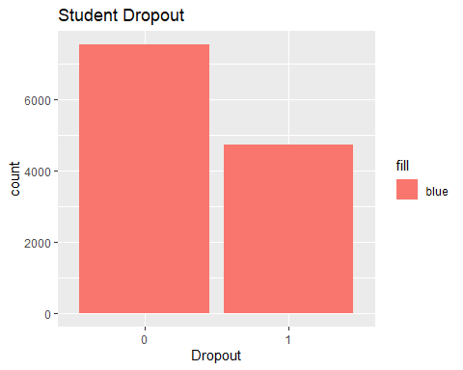

# Marital.Status  
table(TRAIN_DATA$Marital.Status,TRAIN_DATA$Dropout,exclude = NULL)

##   
## 0 1  
## 0 0  
## Divorced 136 72  
## Married 616 308  
## Separated 108 77  
## Single 5777 3326  
## <NA> 890 951

ggplot(data = TRAIN_DATA) +  
 ggtitle("Marital.Status grouped by dropout")+  
 geom_bar(mapping = aes(x = Marital.Status,fill=Dropout))

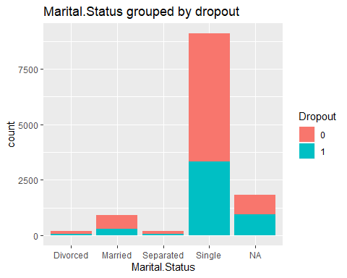

# Father.s.Highest.Grade.Level  
table(TRAIN_DATA$Father.s.Highest.Grade.Level,TRAIN_DATA$Dropout,exclude = NULL)

##   
## 0 1  
## 0 0  
## College 1959 957  
## High School 2893 1685  
## Middle School 755 446  
## Unknown 961 637  
## <NA> 959 1009

ggplot(data = TRAIN_DATA) +  
 ggtitle("Father.s.Highest.Grade.Level grouped by dropout")+  
 geom_bar(mapping = aes(x = Father.s.Highest.Grade.Level,fill=Dropout))

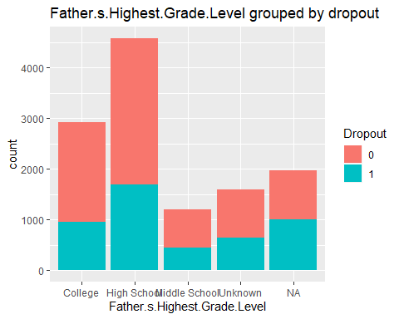

# Mother.s.Highest.Grade.Level  
table(TRAIN_DATA$Mother.s.Highest.Grade.Level,TRAIN_DATA$Dropout,exclude = NULL)

##   
## 0 1  
## 0 0  
## College 1824 1072  
## High School 2827 1689  
## Middle School 698 455  
## Unknown 1055 480  
## <NA> 1123 1038

ggplot(data = TRAIN_DATA) +  
 ggtitle("Mother.s.Highest.Grade.Level grouped by dropout")+  
 geom_bar(mapping = aes(x = Mother.s.Highest.Grade.Level,fill=Dropout))

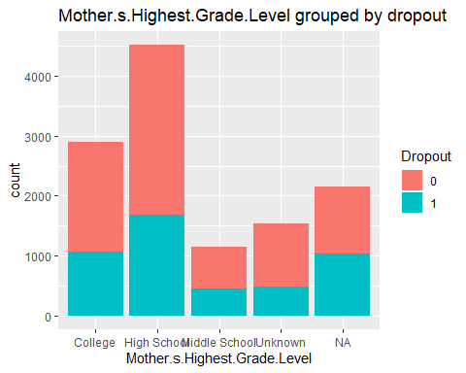

# Housing  
table(TRAIN_DATA$Housing,TRAIN_DATA$Dropout,exclude = NULL)

##   
## 0 1  
## 0 0  
## Off Campus 3044 1802  
## On Campus Housing 884 546  
## With Parent 2697 1423  
## <NA> 902 963

ggplot(data = TRAIN_DATA) +  
 ggtitle("Housing grouped by dropout")+  
 geom_bar(mapping = aes(x = Housing,fill=Dropout))

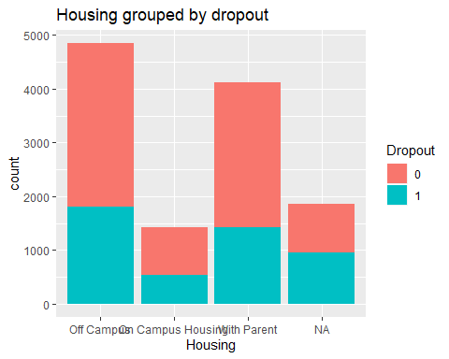

# Cohort  
table(TRAIN_DATA$Cohort,TRAIN_DATA$Dropout,exclude = NULL)

##   
## 0 1  
## 2011-12 943 1188  
## 2012-13 1005 1054  
## 2013-14 1008 928  
## 2014-15 1148 932  
## 2015-16 1552 632  
## 2016-17 1871 0

ggplot(data = TRAIN_DATA) +  
 ggtitle("Cohort grouped by dropout")+  
 geom_bar(mapping = aes(x = Cohort,fill=Dropout))

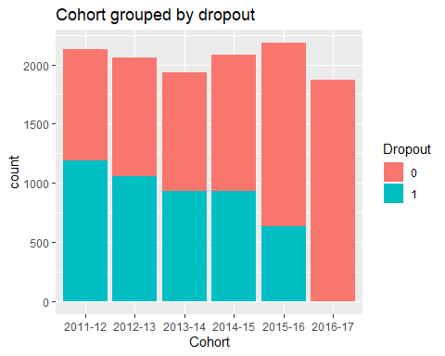

# CohortTerm  
table(TRAIN_DATA$CohortTerm,TRAIN_DATA$Dropout,exclude = NULL)

##   
## 0 1  
## 1 6309 3542  
## 3 1218 1192

ggplot(data = TRAIN_DATA) +  
ggtitle("CohortTerm grouped by dropout")+  
 geom_bar(mapping = aes(x = CohortTerm,fill=Dropout))

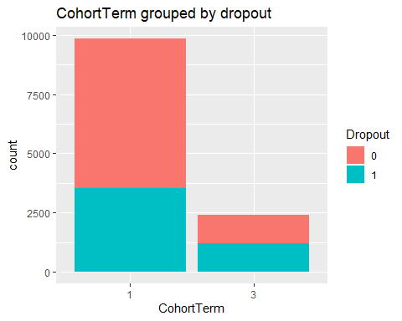

# MathPlacement  
table(TRAIN_DATA$MathPlacement,TRAIN_DATA$Dropout,exclude = NULL)

##   
## 0 1  
## 0 5104 2755  
## 1 2305 1577  
## <NA> 118 402

ggplot(data = TRAIN_DATA) +  
ggtitle("MathPlacement grouped by dropout")+  
 geom_bar(mapping = aes(x = MathPlacement,fill=Dropout))

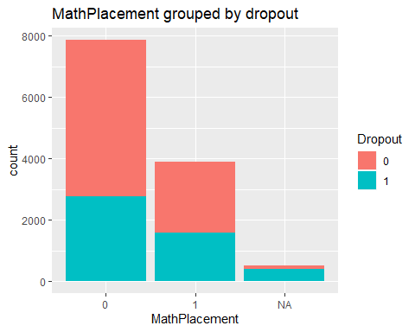

# State  
table(TRAIN_DATA$State,TRAIN_DATA$Dropout,exclude = NULL)

##   
## 0 1  
## 0 0  
## AZ 3 1  
## CA 7 9  
## CO 1 1  
## FL 17 12  
## GA 7 1  
## IL 2 1  
## IN 1 2  
## MA 2 5  
## MD 10 5  
## ME 1 0  
## MI 1 1  
## MN 1 2  
## NC 2 2  
## NJ 7316 4553  
## NV 2 0  
## NY 66 54  
## OH 2 2  
## PA 8 6  
## RI 1 1  
## SC 2 1  
## TN 1 0  
## TX 6 4  
## VA 2 3  
## DC 1 1  
## KS 1 1  
## NM 1 1  
## CT 2 1  
## DE 1 0  
## WA 2 0  
## SD 0 1  
## KY 0 1  
## WI 3 3  
## AL 2 1  
## IA 2 1  
## MO 1 0  
## NE 1 0  
## OK 1 0  
## UT 1 0  
## LA 0 1  
## <NA> 47 56

ggplot(data = TRAIN_DATA) +  
ggtitle("State grouped by dropout")+  
 geom_bar(mapping = aes(x = State,fill=Dropout))

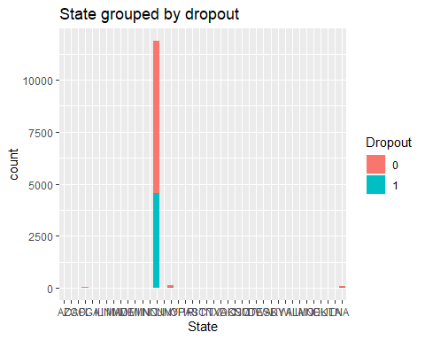

# Gender  
table(TRAIN_DATA$Gender,TRAIN_DATA$Dropout,exclude = NULL)

##   
## 0 1  
## 1 2958 1989  
## 2 4569 2745

ggplot(data = TRAIN_DATA) +  
ggtitle("Gender grouped by dropout")+  
 geom_bar(mapping = aes(x = Gender,fill=Dropout))

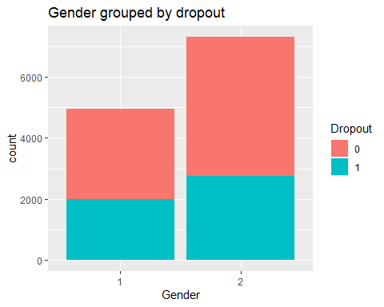

# Hispanic  
table(TRAIN_DATA$Hispanic,TRAIN_DATA$Dropout,exclude = NULL)

##   
## 0 1  
## 0 4528 2901  
## 1 2499 1491  
## <NA> 500 342

ggplot(data = TRAIN_DATA) +  
ggtitle("Hispanic students grouped by dropout")+  
 geom_bar(mapping = aes(x = Hispanic,fill=Dropout))

## Warning: Removed 842 rows containing non-finite values (stat_count).

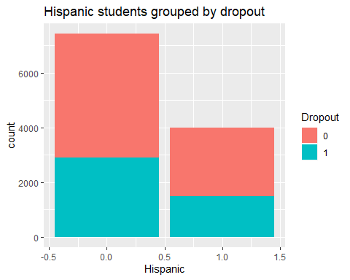

# AmericanIndian  
table(TRAIN_DATA$AmericanIndian,TRAIN_DATA$Dropout,exclude = NULL)

##   
## 0 1  
## 0 7010 4386  
## 1 17 6  
## <NA> 500 342

ggplot(data = TRAIN_DATA) +  
ggtitle("AmericanIndian students grouped by dropout")+  
 geom_bar(mapping = aes(x = AmericanIndian,fill=Dropout))

## Warning: Removed 842 rows containing non-finite values (stat_count).

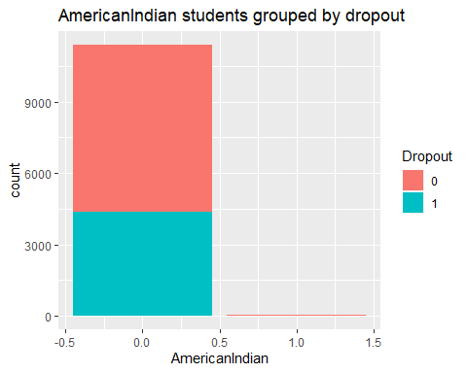

# Asian  
table(TRAIN_DATA$Asian,TRAIN_DATA$Dropout,exclude = NULL)

##   
## 0 1  
## 0 6318 4017  
## 1 709 375  
## <NA> 500 342

ggplot(data = TRAIN_DATA) +  
ggtitle("Asian students grouped by dropout")+  
 geom_bar(mapping = aes(x = Asian,fill=Dropout))

## Warning: Removed 842 rows containing non-finite values (stat_count).

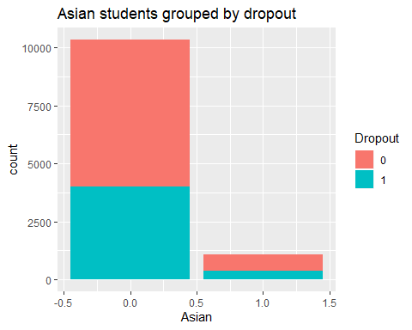

# Black  
table(TRAIN_DATA$Black,TRAIN_DATA$Dropout,exclude = NULL)

##   
## 0 1  
## 0 5514 3264  
## 1 1513 1128  
## <NA> 500 342

ggplot(data = TRAIN_DATA) +  
ggtitle("Black students grouped by dropout")+  
 geom_bar(mapping = aes(x = Black,fill=Dropout))

## Warning: Removed 842 rows containing non-finite values (stat_count).

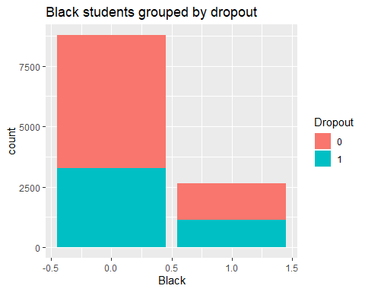

# NativeHawaiian  
table(TRAIN_DATA$NativeHawaiian,TRAIN_DATA$Dropout,exclude = NULL)

##   
## 0 1  
## 0 7007 4391  
## 1 20 1  
## <NA> 500 342

ggplot(data = TRAIN_DATA) +  
 ggtitle("NativeHawaiian students grouped by dropout")+  
 geom_bar(mapping = aes(x = NativeHawaiian,fill=Dropout))

## Warning: Removed 842 rows containing non-finite values (stat_count).

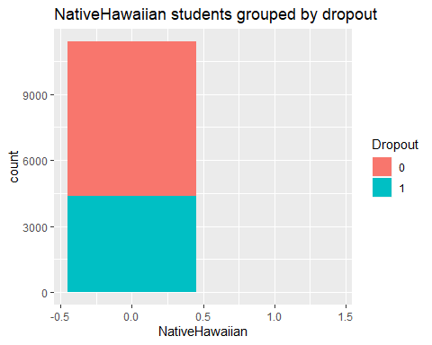

# White  
table(TRAIN_DATA$White,TRAIN_DATA$Dropout,exclude = NULL)

##   
## 0 1  
## 0 5099 3242  
## 1 1928 1150  
## <NA> 500 342

ggplot(data = TRAIN_DATA) +  
ggtitle("White students grouped by dropout")+  
 geom_bar(mapping = aes(x = White,fill=Dropout))

## Warning: Removed 842 rows containing non-finite values (stat_count).

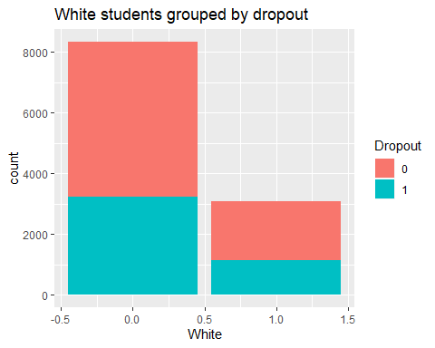

# TwoOrMoreRace  
table(TRAIN_DATA$TwoOrMoreRace,TRAIN_DATA$Dropout,exclude = NULL)

##   
## 0 1  
## 0 6900 4305  
## 1 127 87  
## <NA> 500 342

ggplot(data = TRAIN_DATA) +  
ggtitle("Students withTwoOrMoreRace grouped by dropout")+  
 geom_bar(mapping = aes(x = TwoOrMoreRace,fill=Dropout))

## Warning: Removed 842 rows containing non-finite values (stat_count).

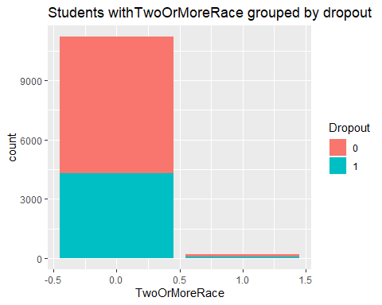

# HSDip  
table(TRAIN_DATA$HSDip,TRAIN_DATA$Dropout,exclude = NULL)

##   
## 0 1  
## 1 7426 4490  
## 2 26 43  
## 4 6 4  
## <NA> 69 197

ggplot(data = TRAIN_DATA) +  
ggtitle("Students HSDip grouped by dropout")+  
 geom_bar(mapping = aes(x = HSDip,fill=Dropout))

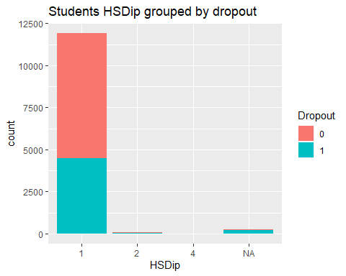

# HighDeg  
table(TRAIN_DATA$HighDeg,TRAIN_DATA$Dropout,exclude = NULL)

##   
## 0 1  
## 0 5132 3578  
## 2 2335 1071  
## 3 59 84  
## 4 1 1

ggplot(data = TRAIN_DATA) +  
 ggtitle('Students HighDeg grouoped by dropout')+  
 geom_bar(mapping = aes(x = HighDeg,fill=Dropout))

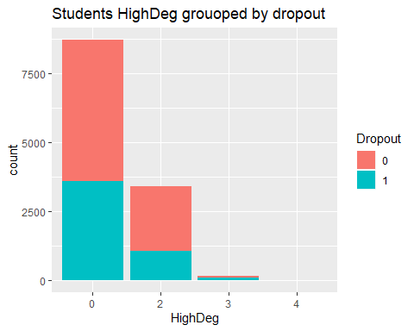

# EngPlacement  
table(TRAIN_DATA$EngPlacement,TRAIN_DATA$Dropout,exclude = NULL)

##   
## 0 1  
## 0 6063 2903  
## 1 1346 1429  
## <NA> 118 402

ggplot(data = TRAIN_DATA) +  
 ggtitle('Students EngPlacement grouped by dropout')+  
 geom_bar(mapping = aes(x = EngPlacement,fill=Dropout))

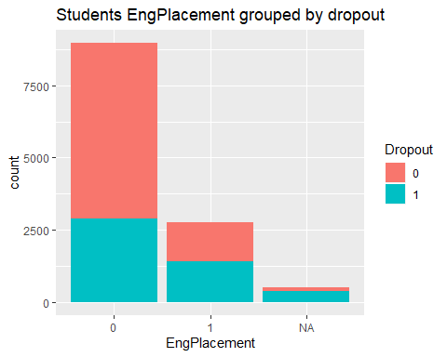

# GatewayMathStatus  
table(TRAIN_DATA$GatewayMathStatus,TRAIN_DATA$Dropout)

##   
## 0 1  
## 0 6551 4243  
## 1 976 491

ggplot(data = TRAIN_DATA) +  
ggtitle('Students GatewayMathStatus grouped by dropout')+  
 geom_bar(mapping = aes(x = GatewayMathStatus,fill=Dropout))

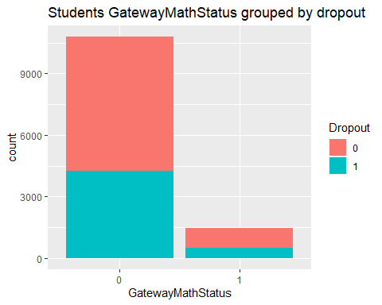

Correlation matrix of the financial aid data to check for multicollinearity among the continuous independent variables (The correlation is expected to be less than 0.5 so as to facilitate regression with multicollinearity)

# Load the GGally package  
library(GGally)

## Registered S3 method overwritten by 'GGally':  
## method from   
## +.gg ggplot2

##   
## Attaching package: 'GGally'

## The following object is masked from 'package:dplyr':  
##   
## nasa

# Create a scatter plot matrix  
vars <- c("Total_loan", "Total_grant", "Total_WorkStudy", "Total_scholarship")  
ggpairs(TRAIN_DATA[vars])

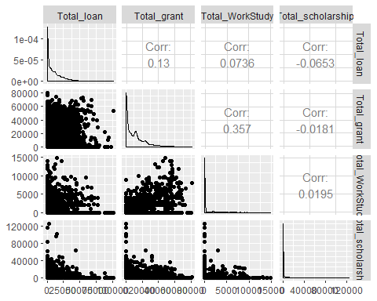

# Load the GGally package  
library(GGally)  
# Create a scatter plot matrix  
vars <- c("Adjusted.Gross.Income","Parent.Adjusted.Gross.Income","CumLoanAtEntry")  
ggpairs(TRAIN_DATA[vars])

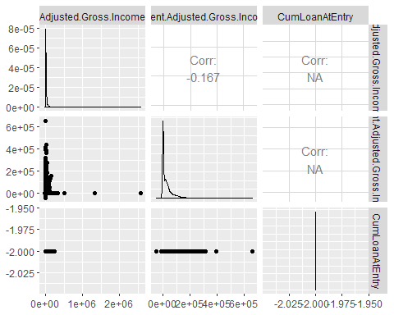

### Hypotheses Tests

Hypotheses tests to test the relation between individual variables and the dependent variable (Dropout) - The Null hypothesis: These variables have no relationship with Dropout. - The Alternative hypothesis: These variables have a relationshop with Dropout. - Decision rule: We reject Null hypothesis if the P-value is less than 0.05 and conclude that the variables have a relationship with Dropout and that Dropout of students is dependent on these variables.

# Test for association  
# Null hypothesis: The dropout of students is not related to gender of a student  
attach(TRAIN_DATA)

## The following objects are masked from financial_aid:  
##   
## Adjusted.Gross.Income, cohort_term, Father.s.Highest.Grade.Level,  
## Housing, Marital.Status, Mother.s.Highest.Grade.Level,  
## Parent.Adjusted.Gross.Income, StudentID

chisq.test(Dropout,Gender)

##   
## Pearson's Chi-squared test with Yates' continuity correction  
##   
## data: Dropout and Gender  
## X-squared = 8.7991, df = 1, p-value = 0.003014

# Null hypothesis: The dropout of students is not related to Marital.Status of a student   
chisq.test(Marital.Status,Dropout)

##   
## Pearson's Chi-squared test  
##   
## data: Marital.Status and Dropout  
## X-squared = 6.2593, df = 3, p-value = 0.09965

# Null hypothesis: The dropout of students is not related to the housing of a student   
chisq.test(Housing,Dropout)

##   
## Pearson's Chi-squared test  
##   
## data: Housing and Dropout  
## X-squared = 9.3589, df = 2, p-value = 0.009284

#Null hypothesis: The dropout of students is not related to the Father.s.Highest.Grade.Level   
chisq.test(Father.s.Highest.Grade.Level,Dropout)

##   
## Pearson's Chi-squared test  
##   
## data: Father.s.Highest.Grade.Level and Dropout  
## X-squared = 24.901, df = 3, p-value = 1.62e-05

# Null hypothesis: The dropout of students is not related to the Mother.s.Highest.Grade.Level   
chisq.test(Mother.s.Highest.Grade.Level,Dropout)

##   
## Pearson's Chi-squared test  
##   
## data: Mother.s.Highest.Grade.Level and Dropout  
## X-squared = 24.326, df = 3, p-value = 2.136e-05

# Null hypothesis: The dropout of students is not related to GatewayMathStatus of the student  
chisq.test(GatewayEnglishStatus,Dropout)

##   
## Pearson's Chi-squared test with Yates' continuity correction  
##   
## data: GatewayEnglishStatus and Dropout  
## X-squared = 99.031, df = 1, p-value < 2.2e-16

NOTE: Most variables had a relationship with dropout except marital status with p-value: 0.09 (p-value>0.05) where we do not reject null hypothesis and conclude that there is no enough statistical evidence to support the claim that dropout of students is related to mariatal status of students.

### Imputation of Missing Values

Summarize and look for the count of NA’s in Individual variables

summary(TRAIN_DATA)

## StudentID Dropout cohort_term Marital.Status Adjusted.Gross.Income  
## Min. : 20932 0:7527 1:9851 : 0 Min. : -24326   
## 1st Qu.:305164 1:4734 3:2410 Divorced : 208 1st Qu.: 0   
## Median :321580 Married : 924 Median : 2768   
## Mean :316079 Separated: 185 Mean : 13263   
## 3rd Qu.:343608 Single :9103 3rd Qu.: 16491   
## Max. :359783 NA's :1841 Max. :2576425   
## NA's :1841   
## Parent.Adjusted.Gross.Income Father.s.Highest.Grade.Level  
## Min. :-49406 : 0   
## 1st Qu.: 0 College :2916   
## Median : 12373 High School :4578   
## Mean : 28318 Middle School:1201   
## 3rd Qu.: 38805 Unknown :1598   
## Max. :657631 NA's :1968   
## NA's :1841   
## Mother.s.Highest.Grade.Level Housing Total_loan   
## : 0 : 0 Min. : 0   
## College :2896 Off Campus :4846 1st Qu.: 0   
## High School :4516 On Campus Housing:1430 Median : 3745   
## Middle School:1153 With Parent :4120 Mean : 8834   
## Unknown :1535 NA's :1865 3rd Qu.: 13429   
## NA's :2161 Max. :100960   
##   
## Total_grant Total_scholarship Total_WorkStudy Cohort CohortTerm  
## Min. : 0 Min. : 0 Min. : 0.0 2011-12:2131 1:9851   
## 1st Qu.: 0 1st Qu.: 0 1st Qu.: 0.0 2012-13:2059 3:2410   
## Median : 5265 Median : 0 Median : 0.0 2013-14:1936   
## Mean : 9690 Mean : 1170 Mean : 208.5 2014-15:2080   
## 3rd Qu.:14100 3rd Qu.: 0 3rd Qu.: 0.0 2015-16:2184   
## Max. :80873 Max. :125497 Max. :14820.0 2016-17:1871   
##   
## Campus Address1 Address2   
## NA's:12261 NJCU-Registrar's Office: 6 1 : 14   
## Summit Apts : 5 2 : 11   
## Jackson Garden Apt : 4 Apt 2 : 10   
## Westview Towers : 4 2039 John F Kennedy Blvd: 6   
## John F : 4 2nd Floor : 5   
## (Other) :12135 (Other) : 309   
## NA's : 103 NA's :11906   
## City State Zip RegistrationDate   
## Jersey City :3285 NJ :11869 Min. : 747 Min. :20110111   
## Bayonne :1138 NY : 120 1st Qu.: 7060 1st Qu.:20120710   
## Newark : 683 FL : 29 Median : 7304 Median :20140122   
## North Bergen: 557 CA : 16 Mean : 7800 Mean :20136172   
## Union City : 549 MD : 15 3rd Qu.: 7307 3rd Qu.:20150624   
## (Other) :5945 (Other): 109 Max. :98118 Max. :20160912   
## NA's : 104 NA's : 103 NA's :121   
## Gender BirthYear BirthMonth Hispanic AmericanIndian   
## 1:4947 1993 :1173 9 :1119 Min. :0.0000 Min. :0.000   
## 2:7314 1994 :1051 7 :1098 1st Qu.:0.0000 1st Qu.:0.000   
## 1995 : 864 8 :1093 Median :0.0000 Median :0.000   
## 1992 : 832 1 :1058 Mean :0.3494 Mean :0.002   
## 1996 : 811 10 :1029 3rd Qu.:1.0000 3rd Qu.:0.000   
## (Other):7529 12 :1028 Max. :1.0000 Max. :1.000   
## NA's : 1 (Other):5836 NA's :842 NA's :842   
## Asian Black NativeHawaiian White   
## Min. :0.0000 Min. :0.0000 Min. :0.0000 Min. :0.0000   
## 1st Qu.:0.0000 1st Qu.:0.0000 1st Qu.:0.0000 1st Qu.:0.0000   
## Median :0.0000 Median :0.0000 Median :0.0000 Median :0.0000   
## Mean :0.0949 Mean :0.2313 Mean :0.0018 Mean :0.2696   
## 3rd Qu.:0.0000 3rd Qu.:0.0000 3rd Qu.:0.0000 3rd Qu.:1.0000   
## Max. :1.0000 Max. :1.0000 Max. :1.0000 Max. :1.0000   
## NA's :842 NA's :842 NA's :842 NA's :842   
## TwoOrMoreRace HSDip HSDipYr HSGPAUnwtd HSGPAWtd   
## Min. :0.0000 1 :11916 Min. :1963 Min. :0.900 Min. : NA   
## 1st Qu.:0.0000 2 : 69 1st Qu.:2011 1st Qu.:2.500 1st Qu.: NA   
## Median :0.0000 4 : 10 Median :2013 Median :2.880 Median : NA   
## Mean :0.0187 NA's: 266 Mean :2013 Mean :2.909 Mean :NaN   
## 3rd Qu.:0.0000 3rd Qu.:2015 3rd Qu.:3.300 3rd Qu.: NA   
## Max. :1.0000 Max. :2016 Max. :4.000 Max. : NA   
## NA's :842 NA's :8921 NA's :8687 NA's :12261   
## FirstGen DualHSSummerEnroll EnrollmentStatus NumColCredAttemptTransfer  
## NA's:12261 Min. :0 1:4952 Min. : -2.00   
## 1st Qu.:0 2:7309 1st Qu.: -2.00   
## Median :0 Median : 24.00   
## Mean :0 Mean : 38.66   
## 3rd Qu.:0 3rd Qu.: 74.00   
## Max. :0 Max. :150.00   
## NA's :370   
## NumColCredAcceptTransfer CumLoanAtEntry HighDeg MathPlacement EngPlacement  
## Min. :-2.00 Min. :-2 0:8710 0 :7859 0 :8966   
## 1st Qu.:-2.00 1st Qu.:-2 2:3406 1 :3882 1 :2775   
## Median :24.00 Median :-2 3: 143 NA's: 520 NA's: 520   
## Mean :32.14 Mean :-2 4: 2   
## 3rd Qu.:66.00 3rd Qu.:-2   
## Max. :96.00 Max. :-2   
## NA's :1 NA's :7309   
## GatewayMathStatus GatewayEnglishStatus CompleteDevMath CompleteDevEnglish  
## 0:10794 0:9967 -2 :7854 -2 :8860   
## 1: 1467 1:2294 0 :1478 0 : 773   
## 0.5 : 443 0.5 : 319   
## 0.25 : 379 1 : 311   
## 1 : 213 0.25 : 197   
## (Other):1371 (Other):1274   
## NA's : 523 NA's : 527   
## Major1 Major2 Complete1 Complete2  
## Min. :-0.50 Min. : 0.003 Min. :0.0000 Min. :0   
## 1st Qu.:26.01 1st Qu.: 6.060 1st Qu.:0.0000 1st Qu.:0   
## Median :43.02 Median : 9.575 Median :0.0000 Median :0   
## Mean :37.02 Mean :12.564 Mean :0.4482 Mean :0   
## 3rd Qu.:51.38 3rd Qu.:13.121 3rd Qu.:0.7778 3rd Qu.:0   
## Max. :54.01 Max. :52.140 Max. :4.0000 Max. :0   
## NA's :129 NA's :11480   
## CompleteCIP1 CompleteCIP2 TransferIntent DegreeTypeSought  
## Min. :-2.0000 Min. :-2 NA's:12261 6:12261   
## 1st Qu.:-2.0000 1st Qu.:-2   
## Median :-2.0000 Median :-2   
## Mean : 0.7489 Mean :-2   
## 3rd Qu.: 2.0927 3rd Qu.:-2   
## Max. :26.0051 Max. :-2   
##   
## TermGPA CumGPA   
## Min. :0.000 Min. :0.000   
## 1st Qu.:2.395 1st Qu.:2.395   
## Median :3.075 Median :3.075   
## Mean :2.817 Mean :2.817   
## 3rd Qu.:3.578 3rd Qu.:3.578   
## Max. :4.000 Max. :4.000   
##

List the columns with missing values

colnames(TRAIN_DATA)[colSums(is.na(TRAIN_DATA)) > 0]

## [1] "Marital.Status" "Adjusted.Gross.Income"   
## [3] "Parent.Adjusted.Gross.Income" "Father.s.Highest.Grade.Level"  
## [5] "Mother.s.Highest.Grade.Level" "Housing"   
## [7] "Campus" "Address1"   
## [9] "Address2" "City"   
## [11] "State" "Zip"   
## [13] "BirthYear" "Hispanic"   
## [15] "AmericanIndian" "Asian"   
## [17] "Black" "NativeHawaiian"   
## [19] "White" "TwoOrMoreRace"   
## [21] "HSDip" "HSDipYr"   
## [23] "HSGPAUnwtd" "HSGPAWtd"   
## [25] "FirstGen" "NumColCredAttemptTransfer"   
## [27] "NumColCredAcceptTransfer" "CumLoanAtEntry"   
## [29] "MathPlacement" "EngPlacement"   
## [31] "CompleteDevMath" "CompleteDevEnglish"   
## [33] "Major1" "Major2"   
## [35] "TransferIntent"

Looking at the summary statistics of the TRAIN data frame there are variables:(‘HSGPAWtd’,‘FirstGen’,‘TransferIntent’,‘Campus’,,‘Major2’) that have missing values close to 90% of the whole column (>11,000), these variables if imputed may introduce bias, hence they were dropped.

* Also drop other variables that are string/nominal in nature: (state, address1, zip, Birthyear, BirthMonth and city) which even if they are imputed they have too many levels hence would increase number predictors unnecessarily after ‘OneHot’ encoding of categorical variables is done later hence too much bias.

library(tidyverse)  
  
drop.cols <- c('HSGPAWtd', 'FirstGen','TransferIntent','Campus','Address1', 'Address2','Major2','State','Zip','BirthYear','BirthMonth','City')  
  
TRAIN_DATA<-TRAIN_DATA %>% select(-drop.cols)  
dim(TRAIN_DATA)

## [1] 12261 47

# which columns have missing data  
colnames(TRAIN_DATA)[colSums(is.na(TRAIN_DATA)) > 0]

## [1] "Marital.Status" "Adjusted.Gross.Income"   
## [3] "Parent.Adjusted.Gross.Income" "Father.s.Highest.Grade.Level"  
## [5] "Mother.s.Highest.Grade.Level" "Housing"   
## [7] "Hispanic" "AmericanIndian"   
## [9] "Asian" "Black"   
## [11] "NativeHawaiian" "White"   
## [13] "TwoOrMoreRace" "HSDip"   
## [15] "HSDipYr" "HSGPAUnwtd"   
## [17] "NumColCredAttemptTransfer" "NumColCredAcceptTransfer"   
## [19] "CumLoanAtEntry" "MathPlacement"   
## [21] "EngPlacement" "CompleteDevMath"   
## [23] "CompleteDevEnglish" "Major1"

Impute categorical variables with mode (most common category level in the variable)

val<-unique(TRAIN_DATA$Marital.Status[!is.na(TRAIN_DATA$Marital.Status)]) # Values in vec_miss  
mode <- val[which.max(tabulate(match(TRAIN_DATA$Marital.Status, val)))] # Mode of vec_miss  
TRAIN_DATA$Marital.Status[is.na(TRAIN_DATA$Marital.Status)]<-mode # Impute by mode  
  
val<-unique(TRAIN_DATA$Father.s.Highest.Grade.Level[!is.na(TRAIN_DATA$Father.s.Highest.Grade.Level)])  
mode<-val[which.max(tabulate(match(TRAIN_DATA$Father.s.Highest.Grade.Level, val)))]   
TRAIN_DATA$Father.s.Highest.Grade.Level[is.na(TRAIN_DATA$Father.s.Highest.Grade.Level)]<-mode   
  
val<-unique(TRAIN_DATA$Mother.s.Highest.Grade.Level[!is.na(TRAIN_DATA$Mother.s.Highest.Grade.Level)])  
mode<-val[which.max(tabulate(match(TRAIN_DATA$Mother.s.Highest.Grade.Level, val)))]   
TRAIN_DATA$Mother.s.Highest.Grade.Level[is.na(TRAIN_DATA$Mother.s.Highest.Grade.Level)]<-mode   
  
val<-unique(TRAIN_DATA$Housing[!is.na(TRAIN_DATA$Housing)])  
mode<-val[which.max(tabulate(match(TRAIN_DATA$Housing, val)))]   
TRAIN_DATA$Housing[is.na(TRAIN_DATA$Housing)]<-mode  
  
  
val<-unique(TRAIN_DATA$EngPlacement[!is.na(TRAIN_DATA$EngPlacement)])  
mode<-val[which.max(tabulate(match(TRAIN_DATA$EngPlacement, val)))]   
TRAIN_DATA$EngPlacement[is.na(TRAIN_DATA$EngPlacement)]<-mode  
  
val<-unique(TRAIN_DATA$MathPlacement[!is.na(TRAIN_DATA$MathPlacement)])  
mode<-val[which.max(tabulate(match(TRAIN_DATA$MathPlacement, val)))]   
TRAIN_DATA$MathPlacement[is.na(TRAIN_DATA$MathPlacement)]<-mode  
  
val<-unique(TRAIN_DATA$CompleteDevEnglish[!is.na(TRAIN_DATA$MathPlacement)])  
mode<-val[which.max(tabulate(match(TRAIN_DATA$CompleteDevEnglish, val)))]   
TRAIN_DATA$CompleteDevEnglish[is.na(TRAIN_DATA$CompleteDevEnglish)]<-mode  
  
val<-unique(TRAIN_DATA$CompleteDevMath[!is.na(TRAIN_DATA$CompleteDevMath)])  
mode<-val[which.max(tabulate(match(TRAIN_DATA$CompleteDevMath, val)))]   
TRAIN_DATA$CompleteDevMath[is.na(TRAIN_DATA$CompleteDevMath)]<-mode  
  
  
val<-unique(TRAIN_DATA$Hispanic[!is.na(TRAIN_DATA$Hispanic)])  
mode<-val[which.max(tabulate(match(TRAIN_DATA$Hispanic, val)))]   
TRAIN_DATA$Hispanic[is.na(TRAIN_DATA$Hispanic)]<-mode   
  
val<-unique(TRAIN_DATA$AmericanIndian[!is.na(TRAIN_DATA$AmericanIndian)])  
mode<-val[which.max(tabulate(match(TRAIN_DATA$AmericanIndian, val)))]   
TRAIN_DATA$AmericanIndian[is.na(TRAIN_DATA$AmericanIndian)]<-mode   
  
val<-unique(TRAIN_DATA$Asian[!is.na(TRAIN_DATA$Asian)])  
mode<-val[which.max(tabulate(match(TRAIN_DATA$Asian, val)))]   
TRAIN_DATA$Asian[is.na(TRAIN_DATA$Asian)]<-mode   
  
val<-unique(TRAIN_DATA$Black[!is.na(TRAIN_DATA$Black)])  
mode<-val[which.max(tabulate(match(TRAIN_DATA$Black, val)))]   
TRAIN_DATA$Black[is.na(TRAIN_DATA$Black)]<-mode   
  
val<-unique(TRAIN_DATA$NativeHawaiian[!is.na(TRAIN_DATA$NativeHawaiian)])  
mode<-val[which.max(tabulate(match(TRAIN_DATA$NativeHawaiian, val)))]   
TRAIN_DATA$NativeHawaiian[is.na(TRAIN_DATA$NativeHawaiian)]<-mode   
  
val<-unique(TRAIN_DATA$White[!is.na(TRAIN_DATA$White)])  
mode<-val[which.max(tabulate(match(TRAIN_DATA$White, val)))]   
TRAIN_DATA$White[is.na(TRAIN_DATA$White)]<-mode   
  
val<-unique(TRAIN_DATA$TwoOrMoreRace[!is.na(TRAIN_DATA$TwoOrMoreRace)])  
mode<-val[which.max(tabulate(match(TRAIN_DATA$TwoOrMoreRace, val)))]   
TRAIN_DATA$TwoOrMoreRace[is.na(TRAIN_DATA$TwoOrMoreRace)]<-mode   
  
val<-unique(TRAIN_DATA$HSDip[!is.na(TRAIN_DATA$HSDip)])  
mode<-val[which.max(tabulate(match(TRAIN_DATA$HSDip, val)))]   
TRAIN_DATA$HSDip[is.na(TRAIN_DATA$HSDip)]<-mode   
  
val<-unique(TRAIN_DATA$HSDipYr[!is.na(TRAIN_DATA$HSDipYr)])  
mode<-val[which.max(tabulate(match(TRAIN_DATA$HSDipYr, val)))]   
TRAIN_DATA$HSDipYr[is.na(TRAIN_DATA$HSDipYr)]<-mode   
  
#Check which columns have missing data to ensure the imputed columns are not there  
colnames(TRAIN_DATA)[colSums(is.na(TRAIN_DATA)) > 0]

## [1] "Adjusted.Gross.Income" "Parent.Adjusted.Gross.Income"  
## [3] "HSGPAUnwtd" "NumColCredAttemptTransfer"   
## [5] "NumColCredAcceptTransfer" "CumLoanAtEntry"   
## [7] "Major1"

Imputing continuous variables

* First check for normal distribution in order to impute with mean or median if they are not normally distributed (bell-shaped histogram and density plot shows normality)
* Adjusted.Gross.Income

#Density plot  
library(ggpubr)

## Loading required package: magrittr

##   
## Attaching package: 'magrittr'

## The following object is masked from 'package:purrr':  
##   
## set_names

## The following object is masked from 'package:tidyr':  
##   
## extract

##   
## Attaching package: 'ggpubr'

## The following object is masked from 'package:plyr':  
##   
## mutate

ggdensity(TRAIN_DATA$Adjusted.Gross.Income,   
 main = "Density plot of tooth length",  
 xlab = "Tooth length")

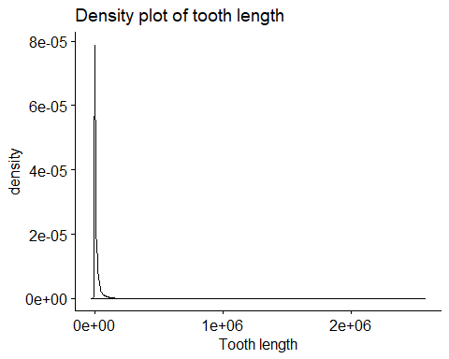

#Histogram  
hist(TRAIN_DATA$Adjusted.Gross.Income) #histogram

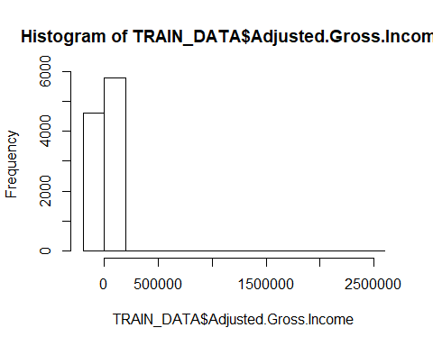

# QQplot  
ggqqplot(TRAIN_DATA$Adjusted.Gross.Income) #qqplot

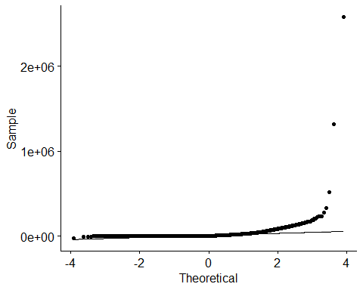

* Total_loan

#Density plot  
library(ggpubr)  
ggdensity(TRAIN_DATA$Total_loan,   
 main = "Density plot of tooth length",  
 xlab = "Tooth length")

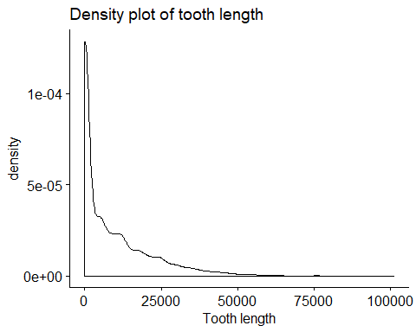

#Histogram  
hist(TRAIN_DATA$Total_loan) #histogram

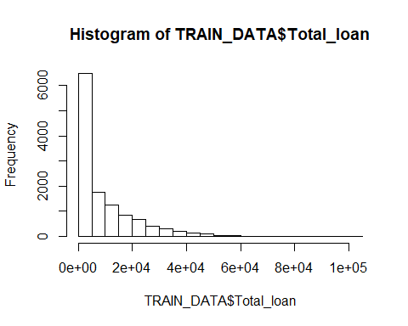

# QQplot  
ggqqplot(TRAIN_DATA$Total_loan) #qqplot

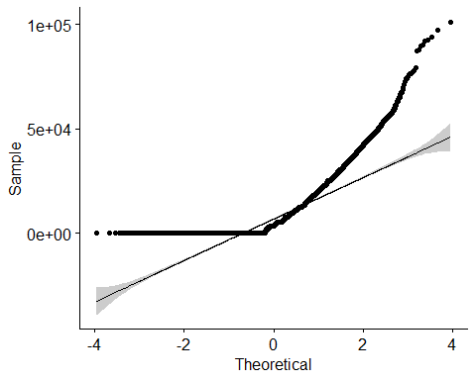

* Total_grant

#Density plot  
library(ggpubr)  
ggdensity(TRAIN_DATA$Total_grant,   
 main = "Density plot of tooth length",  
 xlab = "Tooth length")

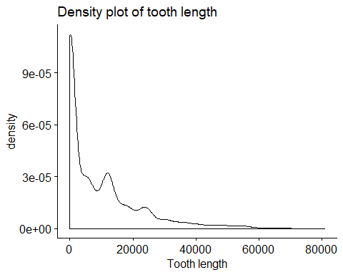

#Histogram  
hist(TRAIN_DATA$Total_grant) #histogram

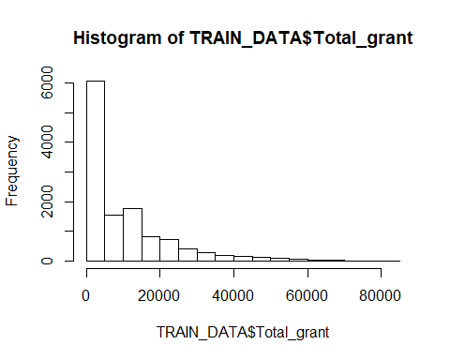

# QQplot  
ggqqplot(TRAIN_DATA$Total_grant) #qqplot

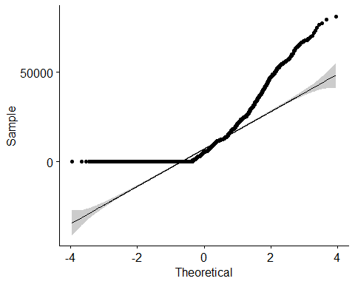

* Total_scholarship

# Density plot  
ggdensity(TRAIN_DATA$Total_scholarship,   
 main = "Density plot of tooth length",  
 xlab = "Tooth length")

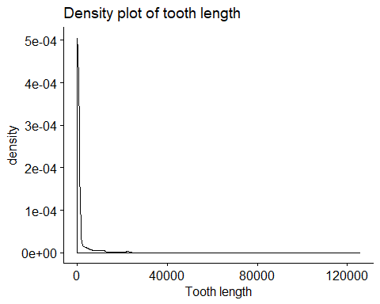

# Histogram  
hist(TRAIN_DATA$Total_scholarship) #histogram

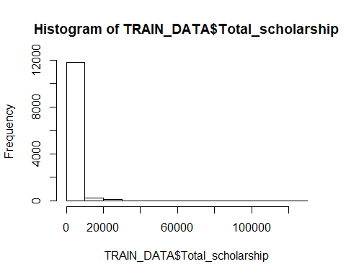

# QQplot  
ggqqplot(TRAIN_DATA$Total_scholarship) #qqplot

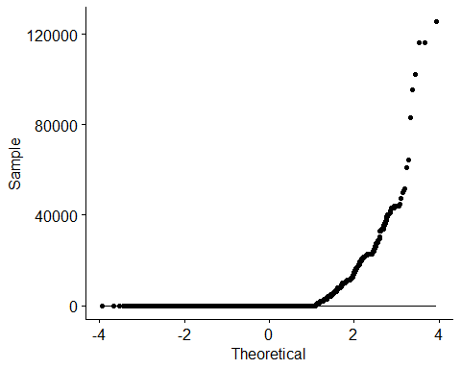

* Total_WorkStudy

# Density plot  
ggdensity(TRAIN_DATA$Total_WorkStudy,   
 main = "Density plot of tooth length",  
 xlab = "Tooth length")

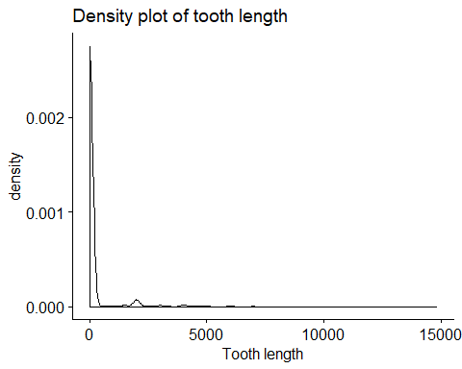

# Histogram  
hist(TRAIN_DATA$Total_WorkStudy) #histogram

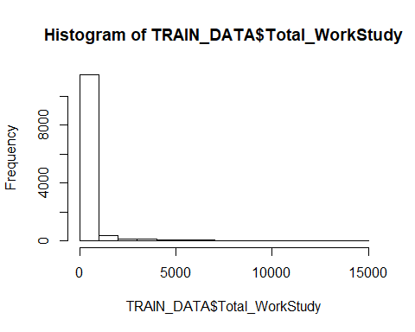

# QQplot  
ggqqplot(TRAIN_DATA$Total_WorkStudy) #qqplot

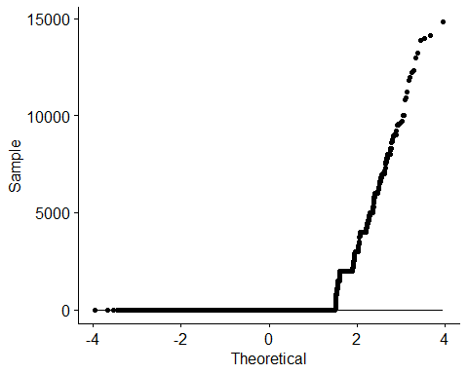

* HSGPAUnwtd

# Density plot  
ggdensity(TRAIN_DATA$HSGPAUnwtd,   
 main = "Density plot of tooth length",  
 xlab = "Tooth length")

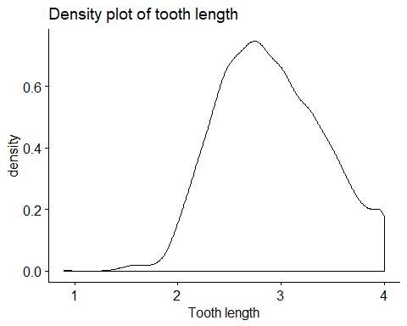

# Histogram  
hist(TRAIN_DATA$HSGPAUnwtd) #histogram

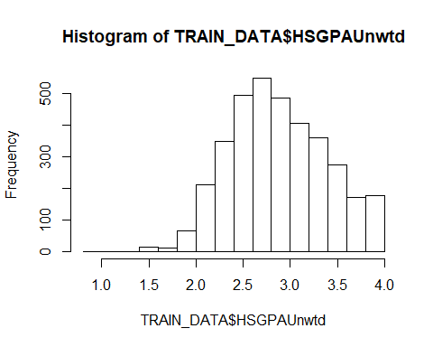

# QQplot  
ggqqplot(TRAIN_DATA$HSGPAUnwtd) #qqplot

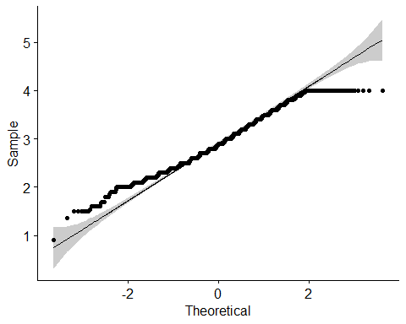

* NumColCredAttemptTransfer

# Density plot  
ggdensity(TRAIN_DATA$NumColCredAttemptTransfer,   
 main = "Density plot of tooth length",  
 xlab = "Tooth length")

## Warning: Removed 370 rows containing non-finite values (stat_density).

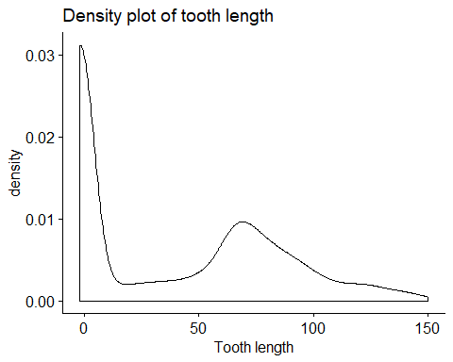

# Histogram  
hist(TRAIN_DATA$NumColCredAcceptTransfer) #histogram

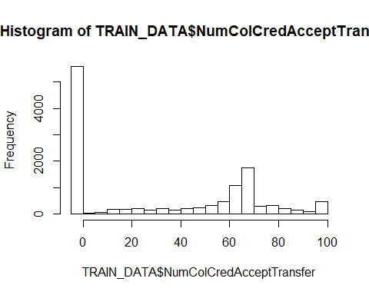

# QQplot  
ggqqplot(TRAIN_DATA$NumColCredAcceptTransfer) #qqplot

## Warning: Removed 1 rows containing non-finite values (stat_qq).

## Warning: Removed 1 rows containing non-finite values (stat_qq_line).  
  
## Warning: Removed 1 rows containing non-finite values (stat_qq_line).

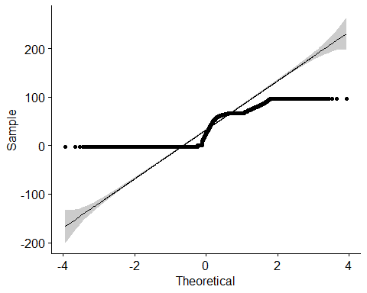

* CumLoanAtEntry

# Density plot  
ggdensity(TRAIN_DATA$CumLoanAtEntry,   
 main = "Density plot of tooth length",  
 xlab = "Tooth length")

## Warning: Removed 7309 rows containing non-finite values (stat_density).

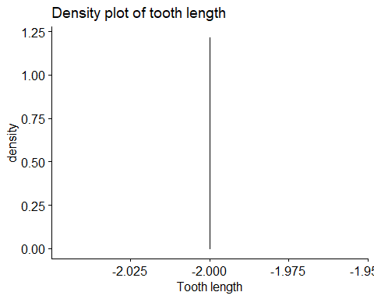

# Histogram  
hist(TRAIN_DATA$CumLoanAtEntry) #histogram

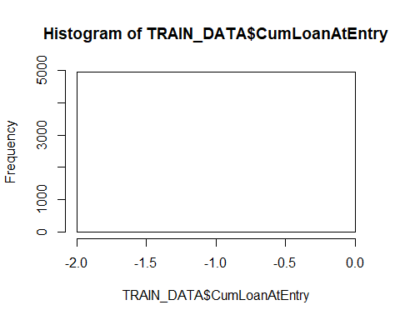

# QQplot  
ggqqplot(TRAIN_DATA$CumLoanAtEntry) #qqplot

## Warning: Removed 7309 rows containing non-finite values (stat_qq).

## Warning: Removed 7309 rows containing non-finite values (stat_qq_line).  
  
## Warning: Removed 7309 rows containing non-finite values (stat_qq_line).

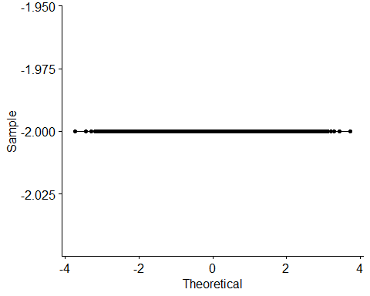

* TermGPA

# Density plot  
ggdensity(TRAIN_DATA$TermGPA,   
 main = "Density plot of tooth length",  
 xlab = "Tooth length")

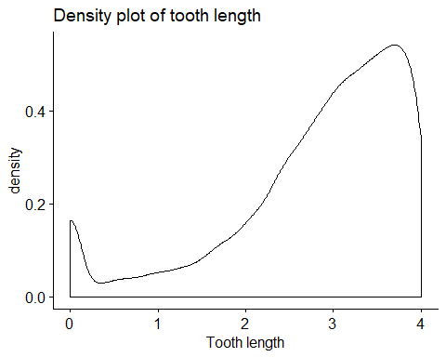

# Histogram  
hist(TRAIN_DATA$TermGPA) #histogram

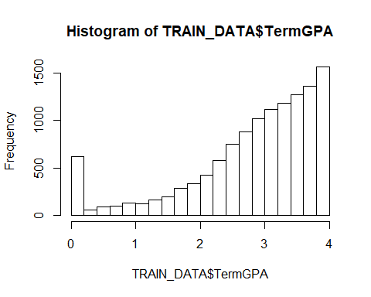

# QQplot  
ggqqplot(TRAIN_DATA$TermGPA) #qqplot

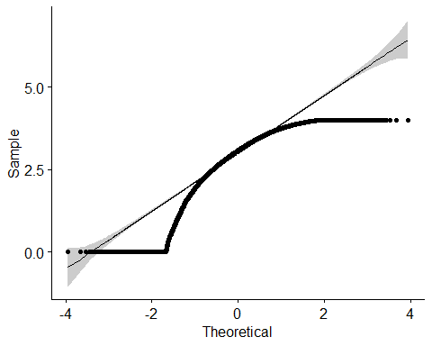

* NOTE: the continous variables did not display normal distribution properties, thus imputation will be done using median intead of mean

#### Impute continuous variables using median

for(i in 1:nrow(TRAIN_DATA)) {  
 TRAIN_DATA[i, ][is.na(TRAIN_DATA[i,])]<-median(as.numeric(TRAIN_DATA[i,]), na.rm = TRUE)  
}  
  
# Count any missing data  
sum(is.na(TRAIN_DATA))

## [1] 0

# which columns have missing data  
colnames(TRAIN_DATA)[colSums(is.na(TRAIN_DATA)) > 0]

## character(0)

TRAIN_Imputed=TRAIN_DATA

## TEST Data Imputation

* Now lets clean and impute missing data in the TEST_DATA as well
* Looking at the dataframe there are variables that have missing values close to 90% of the whole column (>11,000), these variables if imputed may introduce bias, hence they are dropped. Also drop the nominal variables with too many levels or irrelevant qualitative information like BirthMonth, BirthYear, etc.

library(tidyverse)  
  
drop.cols <- c('HSGPAWtd', 'FirstGen','TransferIntent','Campus','Address1', 'Address2','Major2','State','Zip','BirthYear','BirthMonth','City')  
  
  
TEST_DATA<-TEST_DATA %>% select(-drop.cols)  
colnames(TEST_DATA)

## [1] "StudentID" "cohort_term"   
## [3] "Marital.Status" "Adjusted.Gross.Income"   
## [5] "Parent.Adjusted.Gross.Income" "Father.s.Highest.Grade.Level"  
## [7] "Mother.s.Highest.Grade.Level" "Housing"   
## [9] "Total_loan" "Total_grant"   
## [11] "Total_scholarship" "Total_WorkStudy"   
## [13] "Cohort" "CohortTerm"   
## [15] "RegistrationDate" "Gender"   
## [17] "Hispanic" "AmericanIndian"   
## [19] "Asian" "Black"   
## [21] "NativeHawaiian" "White"   
## [23] "TwoOrMoreRace" "HSDip"   
## [25] "HSDipYr" "HSGPAUnwtd"   
## [27] "DualHSSummerEnroll" "EnrollmentStatus"   
## [29] "NumColCredAttemptTransfer" "NumColCredAcceptTransfer"   
## [31] "CumLoanAtEntry" "HighDeg"   
## [33] "MathPlacement" "EngPlacement"   
## [35] "GatewayMathStatus" "GatewayEnglishStatus"   
## [37] "CompleteDevMath" "CompleteDevEnglish"   
## [39] "Major1" "Complete1"   
## [41] "Complete2" "CompleteCIP1"   
## [43] "CompleteCIP2" "DegreeTypeSought"   
## [45] "TermGPA" "CumGPA"

Ensure that all missing values and empty values are captured

# Convert empty spaces and (-1) to NULL in order to facilitate imputation later on  
TEST_DATA[TEST_DATA=="-1"]<-NA  
TEST_DATA[TEST_DATA==""]<-NA  
  
# Check for missing columns  
colnames(TEST_DATA)[colSums(is.na(TEST_DATA)) > 0]

## [1] "Marital.Status" "Adjusted.Gross.Income"   
## [3] "Parent.Adjusted.Gross.Income" "Father.s.Highest.Grade.Level"  
## [5] "Mother.s.Highest.Grade.Level" "Housing"   
## [7] "Hispanic" "AmericanIndian"   
## [9] "Asian" "Black"   
## [11] "NativeHawaiian" "White"   
## [13] "TwoOrMoreRace" "HSDip"   
## [15] "HSDipYr" "HSGPAUnwtd"   
## [17] "NumColCredAttemptTransfer" "CumLoanAtEntry"   
## [19] "MathPlacement" "EngPlacement"   
## [21] "CompleteDevMath" "CompleteDevEnglish"   
## [23] "Major1"

# Impute categorical variables using mode  
  
val<-unique(TEST_DATA$Marital.Status[!is.na(TEST_DATA$Marital.Status)]) # Values in vec_miss  
mode <- val[which.max(tabulate(match(TEST_DATA$Marital.Status, val)))] # Mode of vec_miss  
TEST_DATA$Marital.Status[is.na(TEST_DATA$Marital.Status)]<-mode # Impute by mode  
  
  
val<-unique(TEST_DATA$Father.s.Highest.Grade.Level[!is.na(TEST_DATA$Father.s.Highest.Grade.Level)])  
mode<-val[which.max(tabulate(match(TEST_DATA$Father.s.Highest.Grade.Level, val)))]   
TEST_DATA$Father.s.Highest.Grade.Level[is.na(TEST_DATA$Father.s.Highest.Grade.Level)]<-mode   
  
val<-unique(TEST_DATA$Mother.s.Highest.Grade.Level[!is.na(TEST_DATA$Mother.s.Highest.Grade.Level)])  
mode<-val[which.max(tabulate(match(TEST_DATA$Mother.s.Highest.Grade.Level, val)))]   
TEST_DATA$Mother.s.Highest.Grade.Level[is.na(TEST_DATA$Mother.s.Highest.Grade.Level)]<-mode   
  
val<-unique(TEST_DATA$Housing[!is.na(TEST_DATA$Housing)])  
mode<-val[which.max(tabulate(match(TEST_DATA$Housing, val)))]   
TEST_DATA$Housing[is.na(TEST_DATA$Housing)]<-mode  
  
  
val<-unique(TEST_DATA$EngPlacement[!is.na(TEST_DATA$EngPlacement)])  
mode<-val[which.max(tabulate(match(TEST_DATA$EngPlacement, val)))]   
TEST_DATA$EngPlacement[is.na(TEST_DATA$EngPlacement)]<-mode  
  
  
val<-unique(TEST_DATA$MathPlacement[!is.na(TEST_DATA$MathPlacement)])  
mode<-val[which.max(tabulate(match(TEST_DATA$MathPlacement, val)))]   
TEST_DATA$MathPlacement[is.na(TEST_DATA$MathPlacement)]<-mode  
  
  
val<-unique(TEST_DATA$CompleteDevEnglish[!is.na(TEST_DATA$MathPlacement)])  
mode<-val[which.max(tabulate(match(TEST_DATA$CompleteDevEnglish, val)))]   
TEST_DATA$CompleteDevEnglish[is.na(TEST_DATA$CompleteDevEnglish)]<-mode  
  
  
val<-unique(TEST_DATA$CompleteDevMath[!is.na(TEST_DATA$CompleteDevMath)])  
mode<-val[which.max(tabulate(match(TEST_DATA$CompleteDevMath, val)))]   
TEST_DATA$CompleteDevMath[is.na(TEST_DATA$CompleteDevMath)]<-mode  
  
val<-unique(TEST_DATA$Hispanic[!is.na(TEST_DATA$Hispanic)])  
mode<-val[which.max(tabulate(match(TEST_DATA$Hispanic, val)))]   
TEST_DATA$Hispanic[is.na(TEST_DATA$Hispanic)]<-mode   
  
val<-unique(TEST_DATA$AmericanIndian[!is.na(TEST_DATA$AmericanIndian)])  
mode<-val[which.max(tabulate(match(TEST_DATA$AmericanIndian, val)))]   
TEST_DATA$AmericanIndian[is.na(TEST_DATA$AmericanIndian)]<-mode   
  
val<-unique(TEST_DATA$Asian[!is.na(TEST_DATA$Asian)])  
mode<-val[which.max(tabulate(match(TEST_DATA$Asian, val)))]   
TEST_DATA$Asian[is.na(TEST_DATA$Asian)]<-mode   
  
val<-unique(TEST_DATA$Black[!is.na(TEST_DATA$Black)])  
mode<-val[which.max(tabulate(match(TEST_DATA$Black, val)))]   
TEST_DATA$Black[is.na(TEST_DATA$Black)]<-mode   
  
val<-unique(TEST_DATA$NativeHawaiian[!is.na(TEST_DATA$NativeHawaiian)])  
mode<-val[which.max(tabulate(match(TEST_DATA$NativeHawaiian, val)))]   
TEST_DATA$NativeHawaiian[is.na(TEST_DATA$NativeHawaiian)]<-mode   
  
val<-unique(TEST_DATA$White[!is.na(TEST_DATA$White)])  
mode<-val[which.max(tabulate(match(TEST_DATA$White, val)))]   
TEST_DATA$White[is.na(TEST_DATA$White)]<-mode   
  
val<-unique(TEST_DATA$TwoOrMoreRace[!is.na(TEST_DATA$TwoOrMoreRace)])  
mode<-val[which.max(tabulate(match(TEST_DATA$TwoOrMoreRace, val)))]   
TEST_DATA$TwoOrMoreRace[is.na(TEST_DATA$TwoOrMoreRace)]<-mode   
  
val<-unique(TEST_DATA$HSDip[!is.na(TEST_DATA$HSDip)])  
mode<-val[which.max(tabulate(match(TEST_DATA$HSDip, val)))]   
TEST_DATA$HSDip[is.na(TEST_DATA$HSDip)]<-mode   
  
val<-unique(TEST_DATA$HSDipYr[!is.na(TEST_DATA$HSDipYr)])  
mode<-val[which.max(tabulate(match(TEST_DATA$HSDipYr, val)))]   
TEST_DATA$HSDipYr[is.na(TEST_DATA$HSDipYr)]<-mode   
  
#Check which columns have missing data to ensure the imputed columns are not there  
colnames(TEST_DATA)[colSums(is.na(TEST_DATA)) > 0]

## [1] "Adjusted.Gross.Income" "Parent.Adjusted.Gross.Income"  
## [3] "HSGPAUnwtd" "NumColCredAttemptTransfer"   
## [5] "CumLoanAtEntry" "Major1"

# Impute using median the other numeric variables  
for(i in 1:nrow(TEST_DATA)) {  
 TEST_DATA[i, ][is.na(TEST_DATA[i,])]<-median(as.numeric(TEST_DATA[i,]), na.rm = TRUE)  
}  
  
# Ensure no missing columns left (we expect zero)  
colnames(TEST_DATA)[colSums(is.na(TEST_DATA)) > 0]

## character(0)

TEST_Imputed=TEST_DATA

# FEATURE ENGINEERING

#### Implement feature selection using Boruta package

library(Boruta)

## Loading required package: ranger

# Now is the time to implement and check the performance of boruta package. The syntax of boruta is almost similar to regression (lm) method.  
  
set.seed(123)  
boruta.train <- Boruta(Dropout~.-StudentID, data = TRAIN_Imputed, doTrace = 2)

## 1. run of importance source...

## 2. run of importance source...

## 3. run of importance source...

## 4. run of importance source...

## 5. run of importance source...

## 6. run of importance source...

## 7. run of importance source...

## 8. run of importance source...

## 9. run of importance source...

## 10. run of importance source...

## 11. run of importance source...

## 12. run of importance source...

## 13. run of importance source...

## After 13 iterations, +3.9 mins:

## confirmed 29 attributes: Adjusted.Gross.Income, Cohort, cohort_term, CohortTerm, Complete1 and 24 more;

## rejected 6 attributes: AmericanIndian, Complete2, CompleteCIP2, DegreeTypeSought, DualHSSummerEnroll and 1 more;

## still have 10 attributes left.

## 14. run of importance source...

## 15. run of importance source...

## 16. run of importance source...

## 17. run of importance source...

## After 17 iterations, +5 mins:

## confirmed 1 attribute: Marital.Status;

## rejected 1 attribute: Asian;

## still have 8 attributes left.

## 18. run of importance source...

## 19. run of importance source...

## 20. run of importance source...

## After 20 iterations, +5.7 mins:

## confirmed 1 attribute: GatewayMathStatus;

## rejected 1 attribute: Gender;

## still have 6 attributes left.

## 21. run of importance source...

## 22. run of importance source...

## 23. run of importance source...

## 24. run of importance source...

## After 24 iterations, +6.7 mins:

## confirmed 1 attribute: Father.s.Highest.Grade.Level;

## rejected 1 attribute: HSDip;

## still have 4 attributes left.

## 25. run of importance source...

## 26. run of importance source...

## 27. run of importance source...

## 28. run of importance source...

## 29. run of importance source...

## 30. run of importance source...

## After 30 iterations, +8 mins:

## confirmed 1 attribute: Hispanic;

## still have 3 attributes left.

## 31. run of importance source...

## 32. run of importance source...

## 33. run of importance source...

## 34. run of importance source...

## 35. run of importance source...

## 36. run of importance source...

## 37. run of importance source...

## 38. run of importance source...

## 39. run of importance source...

## 40. run of importance source...

## 41. run of importance source...

## 42. run of importance source...

## 43. run of importance source...

## 44. run of importance source...

## 45. run of importance source...

## 46. run of importance source...

## 47. run of importance source...

## 48. run of importance source...

## 49. run of importance source...

## 50. run of importance source...

## 51. run of importance source...

## 52. run of importance source...

## 53. run of importance source...

## 54. run of importance source...

## 55. run of importance source...

## 56. run of importance source...

## 57. run of importance source...

## 58. run of importance source...

## 59. run of importance source...

## 60. run of importance source...

## 61. run of importance source...

## 62. run of importance source...

## 63. run of importance source...

## 64. run of importance source...

## 65. run of importance source...

## 66. run of importance source...

## 67. run of importance source...

## 68. run of importance source...

## 69. run of importance source...

## 70. run of importance source...

## 71. run of importance source...

## 72. run of importance source...

## 73. run of importance source...

## 74. run of importance source...

## 75. run of importance source...

## 76. run of importance source...

## 77. run of importance source...

## 78. run of importance source...

## 79. run of importance source...

## 80. run of importance source...

## 81. run of importance source...

## 82. run of importance source...

## 83. run of importance source...

## 84. run of importance source...

## 85. run of importance source...

## 86. run of importance source...

## 87. run of importance source...

## 88. run of importance source...

## 89. run of importance source...

## 90. run of importance source...

## 91. run of importance source...

## 92. run of importance source...

## 93. run of importance source...

## 94. run of importance source...

## 95. run of importance source...

## 96. run of importance source...

## 97. run of importance source...

## 98. run of importance source...

## 99. run of importance source...

print(boruta.train)

## Boruta performed 99 iterations in 23.05626 mins.  
## 33 attributes confirmed important: Adjusted.Gross.Income, Cohort,  
## cohort_term, CohortTerm, Complete1 and 28 more;  
## 9 attributes confirmed unimportant: AmericanIndian, Asian, Complete2,  
## CompleteCIP2, DegreeTypeSought and 4 more;  
## 3 tentative attributes left: Black, NativeHawaiian, White;

# Now, we’ll plot the boruta variable importance chart.  
plot(boruta.train, xlab = "", xaxt = "n")  
 lz<-lapply(1:ncol(boruta.train$ImpHistory),function(i)  
 boruta.train$ImpHistory[is.finite(boruta.train$ImpHistory[,i]),i])  
 names(lz) <- colnames(boruta.train$ImpHistory)  
 Labels <- sort(sapply(lz,median))  
 axis(side = 1,las=2,labels = names(Labels),  
 at = 1:ncol(boruta.train$ImpHistory), cex.axis = 0.7)

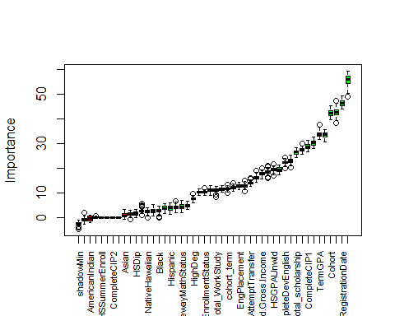

* Blue boxplots correspond to minimal, average and maximum Z score of a shadow attribute. Red, yellow and green boxplots represent Z scores of rejected, tentative and confirmed attributes respectively.
* Now is the time to take decision on tentative attributes. The tentative attributes will be classified as confirmed or rejected by comparing the median Z score of the attributes with the median Z score of the best shadow attribute. Let’s do it.

final.boruta <- TentativeRoughFix(boruta.train)  
print(final.boruta)

## Boruta performed 99 iterations in 23.05626 mins.  
## Tentatives roughfixed over the last 99 iterations.  
## 36 attributes confirmed important: Adjusted.Gross.Income, Black,  
## Cohort, cohort_term, CohortTerm and 31 more;  
## 9 attributes confirmed unimportant: AmericanIndian, Asian, Complete2,  
## CompleteCIP2, DegreeTypeSought and 4 more;

We’ll create a data frame of the final result derived from Boruta.

boruta.df <- attStats(final.boruta)  
class(boruta.df)

## [1] "data.frame"

print(boruta.df)

## meanImp medianImp minImp maxImp  
## cohort_term 11.4644063 11.4890541 9.748180445 13.0654723  
## Marital.Status 4.8001656 4.8011813 3.253116694 6.6341844  
## Adjusted.Gross.Income 17.5834106 17.5396540 15.558539531 19.8420250  
## Parent.Adjusted.Gross.Income 19.3928709 19.2948620 17.277263752 21.2453945  
## Father.s.Highest.Grade.Level 3.7422215 3.7021947 1.540689513 5.6151279  
## Mother.s.Highest.Grade.Level 4.0561694 3.9986348 1.771297864 6.6144269  
## Housing 10.8900635 10.8735631 8.997804971 12.7478507  
## Total_loan 42.5251197 42.4642185 38.298559210 47.2951999  
## Total_grant 55.4045865 55.9224708 48.747025701 59.2426057  
## Total_scholarship 26.2770581 26.4027287 24.225882143 28.2172163  
## Total_WorkStudy 11.0508074 11.0451278 8.198797381 12.6695747  
## Cohort 42.2167406 42.2184180 39.396587241 45.1987074  
## CohortTerm 11.4519135 11.4464315 10.194097204 12.9837520  
## RegistrationDate 46.3384203 46.2726345 43.959364846 49.2282809  
## Gender 1.3115292 1.4183324 -0.808447376 2.7471088  
## Hispanic 3.7528627 3.7986604 1.170683057 5.8318774  
## AmericanIndian -0.4970859 -0.3365582 -2.049282861 0.9825939  
## Asian 0.8789662 0.6885190 -0.866592666 3.0748625  
## Black 2.7563634 2.8204223 -0.263307986 4.4728354  
## NativeHawaiian 2.4073579 2.5199452 0.002989199 3.8246302  
## White 2.5735889 2.5650832 0.532827248 5.1532921  
## TwoOrMoreRace -0.7872690 -0.9413356 -2.636313484 1.7166095  
## HSDip 1.5571518 1.5701008 -0.080618946 3.2618418  
## HSDipYr 18.4271222 18.3762186 16.006170796 20.9253378  
## HSGPAUnwtd 19.2657042 19.2174180 17.028717003 21.4887519  
## DualHSSummerEnroll 0.0000000 0.0000000 0.000000000 0.0000000  
## EnrollmentStatus 10.2968792 10.2425672 8.953024844 12.0079643  
## NumColCredAttemptTransfer 13.8599568 13.8144037 12.533440935 15.9759968  
## NumColCredAcceptTransfer 16.1377078 16.1212677 14.314978327 18.9158072  
## CumLoanAtEntry 10.1817785 10.1916459 8.955420653 11.3805630  
## HighDeg 7.5435041 7.5699375 5.767598541 9.5547090  
## MathPlacement 12.1082994 11.9884078 10.474289978 14.0035540  
## EngPlacement 12.7356027 12.7507211 11.321221199 14.1868192  
## GatewayMathStatus 4.3183216 4.1573323 1.881066736 6.7146035  
## GatewayEnglishStatus 12.7957729 12.8514080 10.394398869 14.7856407  
## CompleteDevMath 22.9028779 22.7871243 20.162655784 25.1403590  
## CompleteDevEnglish 22.1818595 22.2213170 19.872623628 24.1322784  
## Major1 27.4737358 27.4522212 25.608579480 29.9199472  
## Complete1 30.0916956 30.1738274 27.792953306 32.6064043  
## Complete2 0.0000000 0.0000000 0.000000000 0.0000000  
## CompleteCIP1 28.8298497 28.7031964 26.483003792 31.2678100  
## CompleteCIP2 0.0000000 0.0000000 0.000000000 0.0000000  
## DegreeTypeSought 0.0000000 0.0000000 0.000000000 0.0000000  
## TermGPA 33.4941703 33.3777534 31.604048131 37.5905229  
## CumGPA 33.3570918 33.4047757 30.693412868 35.6499898  
## normHits decision  
## cohort_term 1.00000000 Confirmed  
## Marital.Status 0.96969697 Confirmed  
## Adjusted.Gross.Income 1.00000000 Confirmed  
## Parent.Adjusted.Gross.Income 1.00000000 Confirmed  
## Father.s.Highest.Grade.Level 0.88888889 Confirmed  
## Mother.s.Highest.Grade.Level 0.90909091 Confirmed  
## Housing 1.00000000 Confirmed  
## Total_loan 1.00000000 Confirmed  
## Total_grant 1.00000000 Confirmed  
## Total_scholarship 1.00000000 Confirmed  
## Total_WorkStudy 1.00000000 Confirmed  
## Cohort 1.00000000 Confirmed  
## CohortTerm 1.00000000 Confirmed  
## RegistrationDate 1.00000000 Confirmed  
## Gender 0.02020202 Rejected  
## Hispanic 0.83838384 Confirmed  
## AmericanIndian 0.00000000 Rejected  
## Asian 0.01010101 Rejected  
## Black 0.63636364 Confirmed  
## NativeHawaiian 0.44444444 Confirmed  
## White 0.58585859 Confirmed  
## TwoOrMoreRace 0.00000000 Rejected  
## HSDip 0.03030303 Rejected  
## HSDipYr 1.00000000 Confirmed  
## HSGPAUnwtd 1.00000000 Confirmed  
## DualHSSummerEnroll 0.00000000 Rejected  
## EnrollmentStatus 1.00000000 Confirmed  
## NumColCredAttemptTransfer 1.00000000 Confirmed  
## NumColCredAcceptTransfer 1.00000000 Confirmed  
## CumLoanAtEntry 1.00000000 Confirmed  
## HighDeg 1.00000000 Confirmed  
## MathPlacement 1.00000000 Confirmed  
## EngPlacement 1.00000000 Confirmed  
## GatewayMathStatus 0.93939394 Confirmed  
## GatewayEnglishStatus 1.00000000 Confirmed  
## CompleteDevMath 1.00000000 Confirmed  
## CompleteDevEnglish 1.00000000 Confirmed  
## Major1 1.00000000 Confirmed  
## Complete1 1.00000000 Confirmed  
## Complete2 0.00000000 Rejected  
## CompleteCIP1 1.00000000 Confirmed  
## CompleteCIP2 0.00000000 Rejected  
## DegreeTypeSought 0.00000000 Rejected  
## TermGPA 1.00000000 Confirmed  
## CumGPA 1.00000000 Confirmed

It’s time for results now. Let’s obtain the list of confirmed attributes

features=getSelectedAttributes(final.boruta, withTentative = F)   
features #List all selected features

## [1] "cohort_term" "Marital.Status"   
## [3] "Adjusted.Gross.Income" "Parent.Adjusted.Gross.Income"  
## [5] "Father.s.Highest.Grade.Level" "Mother.s.Highest.Grade.Level"  
## [7] "Housing" "Total_loan"   
## [9] "Total_grant" "Total_scholarship"   
## [11] "Total_WorkStudy" "Cohort"   
## [13] "CohortTerm" "RegistrationDate"   
## [15] "Hispanic" "Black"   
## [17] "NativeHawaiian" "White"   
## [19] "HSDipYr" "HSGPAUnwtd"   
## [21] "EnrollmentStatus" "NumColCredAttemptTransfer"   
## [23] "NumColCredAcceptTransfer" "CumLoanAtEntry"   
## [25] "HighDeg" "MathPlacement"   
## [27] "EngPlacement" "GatewayMathStatus"   
## [29] "GatewayEnglishStatus" "CompleteDevMath"   
## [31] "CompleteDevEnglish" "Major1"   
## [33] "Complete1" "CompleteCIP1"   
## [35] "TermGPA" "CumGPA"

# Apply the features onto the TRAIN imputed data  
TRAIN_Features=TRAIN_Imputed[,features]  
  
# Attach the Dropout variable back to the TRAIN Features data frame  
TRAIN_Features$Dropout=TRAIN_Imputed$Dropout  
dim(TRAIN_Features)

## [1] 12261 37

# Also apply the feature selection on the TEST DATA  
TEST_Features=TEST_Imputed[,features]

# Save the TRAIN and TEST features in csv files because we can load them later to avoid the time consuming process of feature engineering.  
  
#write.csv(TRAIN_Features,"D: /Hamed/KAGGLE COMPETITION/FEATURES/clean_features/TRAIN_Features.csv")  
  
#write.csv(TEST_Features,"D:/Hamed/KAGGLE COMPETITION/FEATURES/clean_features/TEST_Features.csv")

#### Let’s understand the parameters used in Boruta as follows:

* maxRuns: maximal number of random forest runs. You can consider increasing this parameter if tentative attributes are left.Default is 100.
* doTrace: It refers to verbosity level. 0 means no tracing. 1 means reporting attribute decision as soon as it is cleared. 2 means all of 1 plus additionally reporting each iteration. Default is 0.
* holdHistory: The full history of importance runs is stored if set to TRUE (Default). Gives a plot of Classifier run vs. Importance when the plotImpHistory function is called to run.

#### Data Standardization:

* Derive Dummy variables out of categorical variables and normalization of continuous variables

# Create Dummy varibales  
library(dummies)

## dummies-1.5.6 provided by Decision Patterns

TRAIN_Features <- dummy.data.frame(TRAIN_Features, names = c("cohort_term","Marital.Status" , "Father.s.Highest.Grade.Level","Mother.s.Highest.Grade.Level",  
 "Housing","Cohort") , sep = ".")

## Warning in model.matrix.default(~x - 1, model.frame(~x - 1), contrasts = FALSE):  
## non-list contrasts argument ignored  
  
## Warning in model.matrix.default(~x - 1, model.frame(~x - 1), contrasts = FALSE):  
## non-list contrasts argument ignored  
  
## Warning in model.matrix.default(~x - 1, model.frame(~x - 1), contrasts = FALSE):  
## non-list contrasts argument ignored  
  
## Warning in model.matrix.default(~x - 1, model.frame(~x - 1), contrasts = FALSE):  
## non-list contrasts argument ignored  
  
## Warning in model.matrix.default(~x - 1, model.frame(~x - 1), contrasts = FALSE):  
## non-list contrasts argument ignored  
  
## Warning in model.matrix.default(~x - 1, model.frame(~x - 1), contrasts = FALSE):  
## non-list contrasts argument ignored

dim(TRAIN_Features)

## [1] 12261 54

#### Standardization of continuous variables

TRAIN DATA transformation

library(caret)

## Loading required package: lattice

##   
## Attaching package: 'caret'

## The following object is masked from 'package:purrr':  
##   
## lift

# calculate the pre-process parameters from the dataset  
preprocessParams <- preProcess(TRAIN_Features[,1:52], method=c("center", "scale"))  
# summarize transform parameters  
print(preprocessParams)

## Created from 12261 samples and 52 variables  
##   
## Pre-processing:  
## - centered (43)  
## - ignored (9)  
## - scaled (43)

# transform the dataset using the parameters  
transformed_train <- predict(preprocessParams, TRAIN_Features[,1:52]) #exclude Dropout variable  
# summarize the transformed dataset  
summary(transformed_train)

## cohort_term.1 cohort_term.3 Marital.Status.Divorced  
## Min. :-2.0217 Min. :-0.4946 Min. :-0.1314   
## 1st Qu.: 0.4946 1st Qu.:-0.4946 1st Qu.:-0.1314   
## Median : 0.4946 Median :-0.4946 Median :-0.1314   
## Mean : 0.0000 Mean : 0.0000 Mean : 0.0000   
## 3rd Qu.: 0.4946 3rd Qu.:-0.4946 3rd Qu.:-0.1314   
## Max. : 0.4946 Max. : 2.0217 Max. : 7.6120   
##   
## Marital.Status.Married Marital.Status.Separated Marital.Status.Single  
## Min. :-0.2855 Min. :-0.1238 Min. :-2.8826   
## 1st Qu.:-0.2855 1st Qu.:-0.1238 1st Qu.: 0.3469   
## Median :-0.2855 Median :-0.1238 Median : 0.3469   
## Mean : 0.0000 Mean : 0.0000 Mean : 0.0000   
## 3rd Qu.:-0.2855 3rd Qu.:-0.1238 3rd Qu.: 0.3469   
## Max. : 3.5026 Max. : 8.0790 Max. : 0.3469   
##   
## Adjusted.Gross.Income Parent.Adjusted.Gross.Income  
## Min. :-1.03904 Min. :-1.7836   
## 1st Qu.:-0.32900 1st Qu.:-0.5842   
## Median :-0.32897 Median :-0.5842   
## Mean : 0.00000 Mean : 0.0000   
## 3rd Qu.: 0.06688 3rd Qu.: 0.2164   
## Max. :74.87315 Max. :15.3805   
##   
## Father.s.Highest.Grade.Level.College Father.s.Highest.Grade.Level.High School  
## Min. :-0.5586 Min. :-1.0702   
## 1st Qu.:-0.5586 1st Qu.:-1.0702   
## Median :-0.5586 Median : 0.9343   
## Mean : 0.0000 Mean : 0.0000   
## 3rd Qu.:-0.5586 3rd Qu.: 0.9343   
## Max. : 1.7901 Max. : 0.9343   
##   
## Father.s.Highest.Grade.Level.Middle School  
## Min. :-0.3295   
## 1st Qu.:-0.3295   
## Median :-0.3295   
## Mean : 0.0000   
## 3rd Qu.:-0.3295   
## Max. : 3.0345   
##   
## Father.s.Highest.Grade.Level.Unknown Mother.s.Highest.Grade.Level.College  
## Min. :-0.3871 Min. :-0.5561   
## 1st Qu.:-0.3871 1st Qu.:-0.5561   
## Median :-0.3871 Median :-0.5561   
## Mean : 0.0000 Mean : 0.0000   
## 3rd Qu.:-0.3871 3rd Qu.:-0.5561   
## Max. : 2.5831 Max. : 1.7982   
##   
## Mother.s.Highest.Grade.Level.High School  
## Min. :-1.0935   
## 1st Qu.:-1.0935   
## Median : 0.9145   
## Mean : 0.0000   
## 3rd Qu.: 0.9145   
## Max. : 0.9145   
##   
## Mother.s.Highest.Grade.Level.Middle School  
## Min. :-0.3222   
## 1st Qu.:-0.3222   
## Median :-0.3222   
## Mean : 0.0000   
## 3rd Qu.:-0.3222   
## Max. : 3.1037   
##   
## Mother.s.Highest.Grade.Level.Unknown Housing.Off Campus  
## Min. :-0.3783 Min. :-1.0996   
## 1st Qu.:-0.3783 1st Qu.:-1.0996   
## Median :-0.3783 Median : 0.9094   
## Mean : 0.0000 Mean : 0.0000   
## 3rd Qu.:-0.3783 3rd Qu.: 0.9094   
## Max. : 2.6433 Max. : 0.9094   
##   
## Housing.On Campus Housing Housing.With Parent Total_loan   
## Min. :-0.3633 Min. :-0.7114 Min. :-0.7311   
## 1st Qu.:-0.3633 1st Qu.:-0.7114 1st Qu.:-0.7311   
## Median :-0.3633 Median :-0.7114 Median :-0.4212   
## Mean : 0.0000 Mean : 0.0000 Mean : 0.0000   
## 3rd Qu.:-0.3633 3rd Qu.: 1.4056 3rd Qu.: 0.3803   
## Max. : 2.7520 Max. : 1.4056 Max. : 7.6244   
##   
## Total_grant Total_scholarship Total_WorkStudy Cohort.2011-12   
## Min. :-0.7725 Min. :-0.2404 Min. :-0.2127 Min. :-0.4586   
## 1st Qu.:-0.7725 1st Qu.:-0.2404 1st Qu.:-0.2127 1st Qu.:-0.4586   
## Median :-0.3528 Median :-0.2404 Median :-0.2127 Median :-0.4586   
## Mean : 0.0000 Mean : 0.0000 Mean : 0.0000 Mean : 0.0000   
## 3rd Qu.: 0.3516 3rd Qu.:-0.2404 3rd Qu.:-0.2127 3rd Qu.:-0.4586   
## Max. : 5.6750 Max. :25.5464 Max. :14.9001 Max. : 2.1802   
##   
## Cohort.2012-13 Cohort.2013-14 Cohort.2014-15 Cohort.2015-16   
## Min. :-0.4492 Min. :-0.433 Min. :-0.452 Min. :-0.4655   
## 1st Qu.:-0.4492 1st Qu.:-0.433 1st Qu.:-0.452 1st Qu.:-0.4655   
## Median :-0.4492 Median :-0.433 Median :-0.452 Median :-0.4655   
## Mean : 0.0000 Mean : 0.000 Mean : 0.000 Mean : 0.0000   
## 3rd Qu.:-0.4492 3rd Qu.:-0.433 3rd Qu.:-0.452 3rd Qu.:-0.4655   
## Max. : 2.2259 Max. : 2.309 Max. : 2.212 Max. : 2.1479   
##   
## Cohort.2016-17 CohortTerm RegistrationDate Hispanic   
## Min. :-0.4243 1:9851 Min. :-1.5339 Min. :-0.6945   
## 1st Qu.:-0.4243 3:2410 1st Qu.:-0.9101 1st Qu.:-0.6945   
## Median :-0.4243 Median : 0.2325 Median :-0.6945   
## Mean : 0.0000 Mean : 0.0000 Mean : 0.0000   
## 3rd Qu.:-0.4243 3rd Qu.: 0.8506 3rd Qu.: 1.4397   
## Max. : 2.3564 Max. : 1.4562 Max. : 1.4397   
##   
## Black NativeHawaiian White HSDipYr   
## Min. :-0.5239 Min. :-0.04142 Min. :-0.5789 Min. :-21.4281   
## 1st Qu.:-0.5239 1st Qu.:-0.04142 1st Qu.:-0.5789 1st Qu.: 0.3636   
## Median :-0.5239 Median :-0.04142 Median :-0.5789 Median : 0.3636   
## Mean : 0.0000 Mean : 0.00000 Mean : 0.0000 Mean : 0.0000   
## 3rd Qu.:-0.5239 3rd Qu.:-0.04142 3rd Qu.: 1.7272 3rd Qu.: 0.3636   
## Max. : 1.9085 Max. :24.14145 Max. : 1.7272 Max. : 0.3636   
##   
## HSGPAUnwtd EnrollmentStatus NumColCredAttemptTransfer  
## Min. :-1.1848 1:4952 Min. :-0.9100   
## 1st Qu.:-0.6341 2:7309 1st Qu.:-0.9100   
## Median :-0.6341 Median :-0.4955   
## Mean : 0.0000 Mean : 0.0000   
## 3rd Qu.: 0.8860 3rd Qu.: 0.8170   
## Max. : 2.6703 Max. : 2.5901   
##   
## NumColCredAcceptTransfer CumLoanAtEntry HighDeg MathPlacement EngPlacement  
## Min. :-0.9887 Min. :-1.2103 0:8710 0:8379 0:9486   
## 1st Qu.:-0.9887 1st Qu.:-1.2103 2:3406 1:3882 1:2775   
## Median :-0.2358 Median : 0.7988 3: 143   
## Mean : 0.0000 Mean : 0.0000 4: 2   
## 3rd Qu.: 0.9805 3rd Qu.: 0.7988   
## Max. : 1.8493 Max. : 1.4685   
##   
## GatewayMathStatus GatewayEnglishStatus CompleteDevMath  
## 0:10794 0:9967 -2 :8377   
## 1: 1467 1:2294 0 :1478   
## 0.5 : 443   
## 0.25 : 379   
## 1 : 213   
## 0.333333333333333: 205   
## (Other) :1166   
## CompleteDevEnglish Major1 Complete1   
## -2 :9387 Min. :-2.2302 Min. :-0.5385   
## 0 : 773 1st Qu.:-0.6385 1st Qu.:-0.5385   
## 0.5 : 319 Median : 0.3827 Median :-0.5385   
## 1 : 311 Mean : 0.0000 Mean : 0.0000   
## 0.25 : 197 3rd Qu.: 0.8847 3rd Qu.: 0.3959   
## 0.333333333333333: 170 Max. : 1.0426 Max. : 4.2669   
## (Other) :1104   
## CompleteCIP1 TermGPA   
## Min. :-0.5149 Min. :-2.7625   
## 1st Qu.:-0.5149 1st Qu.:-0.4139   
## Median :-0.5149 Median : 0.2529   
## Mean : 0.0000 Mean : 0.0000   
## 3rd Qu.: 0.2517 3rd Qu.: 0.7465   
## Max. : 4.7306 Max. : 1.1600   
##

dim(transformed_train)

## [1] 12261 52

transformed_train$Dropout=TRAIN_Features$Dropout #re-include Dropout variable  
  
  
# save the claen and transformed features into a local folder for future use  
#write.csv(transformed_train,"D:/Hamed/KAGGLE COMPETITION/FEATURES/clean_features/transformed_train.csv")

TEST DATA transformation

vars=c("cohort_term","Marital.Status" ,"Father.s.Highest.Grade.Level",  
 "Mother.s.Highest.Grade.Level","Housing","Cohort")  
TEST_Features[,vars] <- lapply(TEST_Features[,vars] , factor)  
TEST_Features<-dummy.data.frame(TEST_Features,names = vars,sep=".")  
dim(TEST_Features)

## [1] 1000 53

# Also standardize the test features  
library(caret)  
# calculate the pre-process parameters from the dataset  
preprocessParams <- preProcess(TEST_Features[,1:52], method=c("center", "scale"))  
# summarize transform parameters  
print(preprocessParams)

## Created from 1000 samples and 52 variables  
##   
## Pre-processing:  
## - centered (52)  
## - ignored (0)  
## - scaled (52)

# transform the dataset using the parameters  
transformed_test <- predict(preprocessParams, TEST_Features[,1:52])  
# summarize the transformed dataset  
summary(transformed_test)

## cohort_term.1 cohort_term.3 Marital.Status.Divorced  
## Min. :-2.1048 Min. :-0.4746 Min. :-0.1353   
## 1st Qu.: 0.4746 1st Qu.:-0.4746 1st Qu.:-0.1353   
## Median : 0.4746 Median :-0.4746 Median :-0.1353   
## Mean : 0.0000 Mean : 0.0000 Mean : 0.0000   
## 3rd Qu.: 0.4746 3rd Qu.:-0.4746 3rd Qu.:-0.1353   
## Max. : 0.4746 Max. : 2.1048 Max. : 7.3825   
## Marital.Status.Married Marital.Status.Separated Marital.Status.Single  
## Min. :-0.27 Min. :-0.08976 Min. :-3.1030   
## 1st Qu.:-0.27 1st Qu.:-0.08976 1st Qu.: 0.3219   
## Median :-0.27 Median :-0.08976 Median : 0.3219   
## Mean : 0.00 Mean : 0.00000 Mean : 0.0000   
## 3rd Qu.:-0.27 3rd Qu.:-0.08976 3rd Qu.: 0.3219   
## Max. : 3.70 Max. :11.12996 Max. : 0.3219   
## Adjusted.Gross.Income Parent.Adjusted.Gross.Income  
## Min. :-0.5076 Min. :-2.2776   
## 1st Qu.:-0.4528 1st Qu.:-0.6290   
## Median :-0.4528 Median :-0.4771   
## Mean : 0.0000 Mean : 0.0000   
## 3rd Qu.: 0.0329 3rd Qu.: 0.2477   
## Max. : 8.7652 Max. : 9.7366   
## Father.s.Highest.Grade.Level.College Father.s.Highest.Grade.Level.High School  
## Min. :-0.5848 Min. :-1.03   
## 1st Qu.:-0.5848 1st Qu.:-1.03   
## Median :-0.5848 Median : 0.97   
## Mean : 0.0000 Mean : 0.00   
## 3rd Qu.: 1.7084 3rd Qu.: 0.97   
## Max. : 1.7084 Max. : 0.97   
## Father.s.Highest.Grade.Level.Middle School  
## Min. :-0.3387   
## 1st Qu.:-0.3387   
## Median :-0.3387   
## Mean : 0.0000   
## 3rd Qu.:-0.3387   
## Max. : 2.9496   
## Father.s.Highest.Grade.Level.Unknown Mother.s.Highest.Grade.Level.College  
## Min. :-0.3812 Min. :-0.554   
## 1st Qu.:-0.3812 1st Qu.:-0.554   
## Median :-0.3812 Median :-0.554   
## Mean : 0.0000 Mean : 0.000   
## 3rd Qu.:-0.3812 3rd Qu.:-0.554   
## Max. : 2.6205 Max. : 1.803   
## Mother.s.Highest.Grade.Level.High School  
## Min. :-1.1005   
## 1st Qu.:-1.1005   
## Median : 0.9077   
## Mean : 0.0000   
## 3rd Qu.: 0.9077   
## Max. : 0.9077   
## Mother.s.Highest.Grade.Level.Middle School  
## Min. :-0.3442   
## 1st Qu.:-0.3442   
## Median :-0.3442   
## Mean : 0.0000   
## 3rd Qu.:-0.3442   
## Max. : 2.9027   
## Mother.s.Highest.Grade.Level.Unknown Housing.Off Campus  
## Min. :-0.3532 Min. :-0.719   
## 1st Qu.:-0.3532 1st Qu.:-0.719   
## Median :-0.3532 Median :-0.719   
## Mean : 0.0000 Mean : 0.000   
## 3rd Qu.:-0.3532 3rd Qu.: 1.389   
## Max. : 2.8286 Max. : 1.389   
## Housing.On Campus Housing Housing.With Parent Total_loan   
## Min. :-0.4066 Min. :-1.0341 Min. :-0.7157   
## 1st Qu.:-0.4066 1st Qu.:-1.0341 1st Qu.:-0.7157   
## Median :-0.4066 Median : 0.9661 Median :-0.4342   
## Mean : 0.0000 Mean : 0.0000 Mean : 0.0000   
## 3rd Qu.:-0.4066 3rd Qu.: 0.9661 3rd Qu.: 0.3597   
## Max. : 2.4569 Max. : 0.9661 Max. : 5.5309   
## Total_grant Total_scholarship Total_WorkStudy Cohort.2011-12   
## Min. :-0.7952 Min. :-0.2861 Min. :-0.2608 Min. :-0.4539   
## 1st Qu.:-0.7952 1st Qu.:-0.2861 1st Qu.:-0.2608 1st Qu.:-0.4539   
## Median :-0.3840 Median :-0.2861 Median :-0.2608 Median :-0.4539   
## Mean : 0.0000 Mean : 0.0000 Mean : 0.0000 Mean : 0.0000   
## 3rd Qu.: 0.3815 3rd Qu.:-0.2861 3rd Qu.:-0.2608 3rd Qu.:-0.4539   
## Max. : 4.6655 Max. :11.8541 Max. : 8.5800 Max. : 2.2007   
## Cohort.2012-13 Cohort.2013-14 Cohort.2014-15 Cohort.2015-16   
## Min. :-0.5122 Min. :-0.4049 Min. :-0.4427 Min. :-0.4475   
## 1st Qu.:-0.5122 1st Qu.:-0.4049 1st Qu.:-0.4427 1st Qu.:-0.4475   
## Median :-0.5122 Median :-0.4049 Median :-0.4427 Median :-0.4475   
## Mean : 0.0000 Mean : 0.0000 Mean : 0.0000 Mean : 0.0000   
## 3rd Qu.:-0.5122 3rd Qu.:-0.4049 3rd Qu.:-0.4427 3rd Qu.:-0.4475   
## Max. : 1.9504 Max. : 2.4670 Max. : 2.2566 Max. : 2.2323   
## Cohort.2016-17 CohortTerm RegistrationDate Hispanic   
## Min. :-0.4182 Min. :-0.4746 Min. :-1.4823 Min. :-0.7062   
## 1st Qu.:-0.4182 1st Qu.:-0.4746 1st Qu.:-0.8603 1st Qu.:-0.7062   
## Median :-0.4182 Median :-0.4746 Median :-0.2573 Median :-0.7062   
## Mean : 0.0000 Mean : 0.0000 Mean : 0.0000 Mean : 0.0000   
## 3rd Qu.:-0.4182 3rd Qu.:-0.4746 3rd Qu.: 0.8975 3rd Qu.: 1.4146   
## Max. : 2.3887 Max. : 2.1048 Max. : 1.5023 Max. : 1.4146   
## Black NativeHawaiian White HSDipYr   
## Min. :-0.4935 Min. :-0.03162 Min. :-0.6032 Min. :-16.653   
## 1st Qu.:-0.4935 1st Qu.:-0.03162 1st Qu.:-0.6032 1st Qu.: -0.074   
## Median :-0.4935 Median :-0.03162 Median :-0.6032 Median : -0.074   
## Mean : 0.0000 Mean : 0.00000 Mean : 0.0000 Mean : 0.000   
## 3rd Qu.:-0.4935 3rd Qu.:-0.03162 3rd Qu.: 1.6561 3rd Qu.: -0.074   
## Max. : 2.0243 Max. :31.59115 Max. : 1.6561 Max. : 1.543   
## HSGPAUnwtd EnrollmentStatus NumColCredAttemptTransfer  
## Min. :-1.3679 Min. :-0.9995 Min. :-0.7866   
## 1st Qu.:-0.4940 1st Qu.:-0.9995 1st Qu.:-0.7866   
## Median :-0.4940 Median : 0.0000 Median :-0.7627   
## Mean : 0.0000 Mean : 0.0000 Mean : 0.0000   
## 3rd Qu.: 0.9764 3rd Qu.: 0.9995 3rd Qu.: 0.8810   
## Max. : 2.1277 Max. : 0.9995 Max. : 2.8344   
## NumColCredAcceptTransfer CumLoanAtEntry HighDeg MathPlacement   
## Min. :-0.8511 Min. :-0.9745 Min. :-0.5677 Min. :-0.8042   
## 1st Qu.:-0.8511 1st Qu.:-0.9745 1st Qu.:-0.5677 1st Qu.:-0.8042   
## Median :-0.8219 Median :-0.2937 Median :-0.5677 Median :-0.8042   
## Mean : 0.0000 Mean : 0.0000 Mean : 0.0000 Mean : 0.0000   
## 3rd Qu.: 1.1042 3rd Qu.: 1.0680 3rd Qu.:-0.5677 3rd Qu.: 1.2422   
## Max. : 2.0089 Max. : 1.7489 Max. : 2.7849 Max. : 1.2422   
## EngPlacement GatewayMathStatus GatewayEnglishStatus CompleteDevMath   
## Min. :-0.6156 Min. :-0.3708 Min. :-0.5432 Min. :-0.7957   
## 1st Qu.:-0.6156 1st Qu.:-0.3708 1st Qu.:-0.5432 1st Qu.:-0.7957   
## Median :-0.6156 Median :-0.3708 Median :-0.5432 Median :-0.7957   
## Mean : 0.0000 Mean : 0.0000 Mean : 0.0000 Mean : 0.0000   
## 3rd Qu.: 1.6229 3rd Qu.:-0.3708 3rd Qu.:-0.5432 3rd Qu.: 1.0914   
## Max. : 1.6229 Max. : 2.6939 Max. : 1.8392 Max. : 1.9217   
## CompleteDevEnglish Major1 Complete1 CompleteCIP1   
## Min. :-0.6124 Min. :-2.0334 Min. :-0.5365 Min. :-0.5136   
## 1st Qu.:-0.6124 1st Qu.:-0.7152 1st Qu.:-0.5365 1st Qu.:-0.5136   
## Median :-0.6124 Median : 0.4311 Median :-0.5365 Median :-0.5136   
## Mean : 0.0000 Mean : 0.0000 Mean : 0.0000 Mean : 0.0000   
## 3rd Qu.: 1.3061 3rd Qu.: 0.9100 3rd Qu.: 0.4380 3rd Qu.: 0.2607   
## Max. : 2.2653 Max. : 1.0607 Max. : 4.4753 Max. : 4.6529   
## TermGPA   
## Min. :-2.7566   
## 1st Qu.:-0.3919   
## Median : 0.2765   
## Mean : 0.0000   
## 3rd Qu.: 0.7241   
## Max. : 1.1522

dim(transformed_test)

## [1] 1000 52

# save the claen and transformed features into a local folder for future use  
#write.csv(transformed_test,"D:/Hamed/KAGGLE COMPETITION/FEATURES/clean_features/transformed_test.csv")